**SECTION 15) aws monitoring and audit: cloudwatch , xray and cloudtrail**

**Very important as a developer**

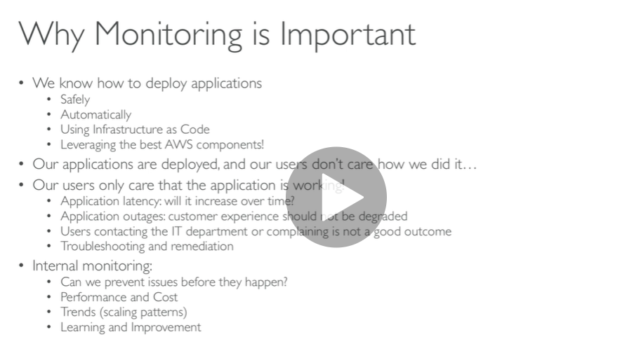

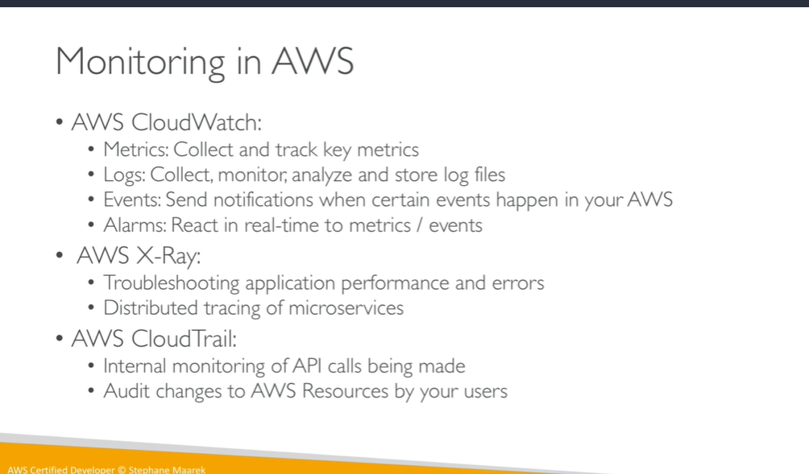

**AWS CLOUDWATCH Metrics**

**We can create cloudwatch dashboard for metrics (cpu utilization)**

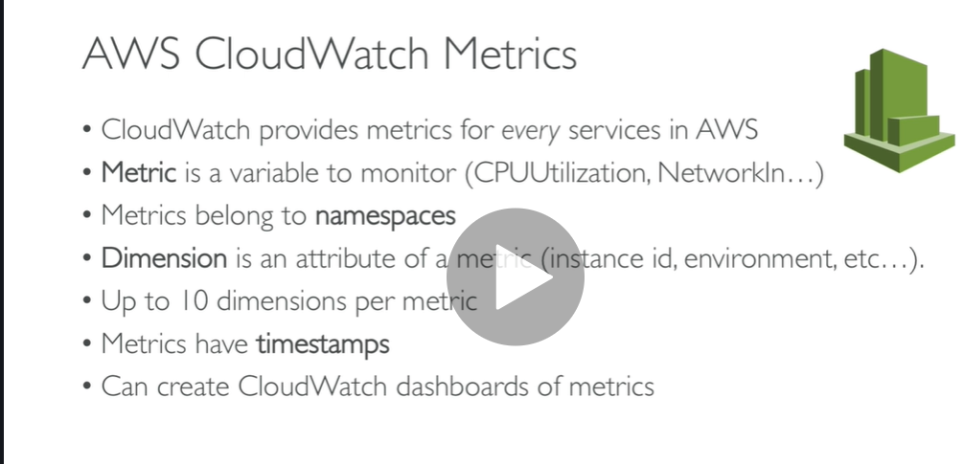

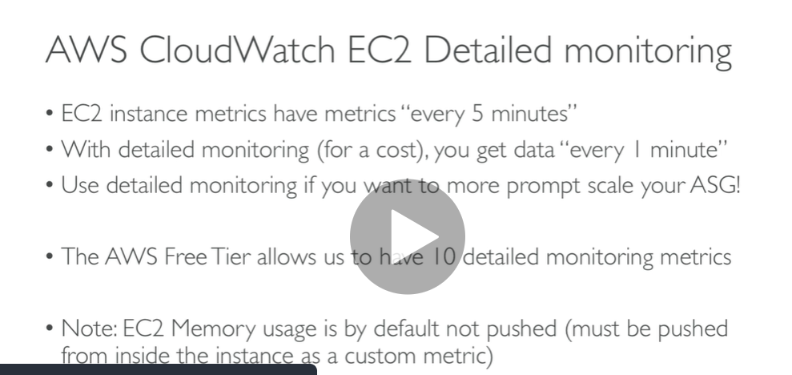

**If we will send so much matric to cloudwatch then we will get throtle error**

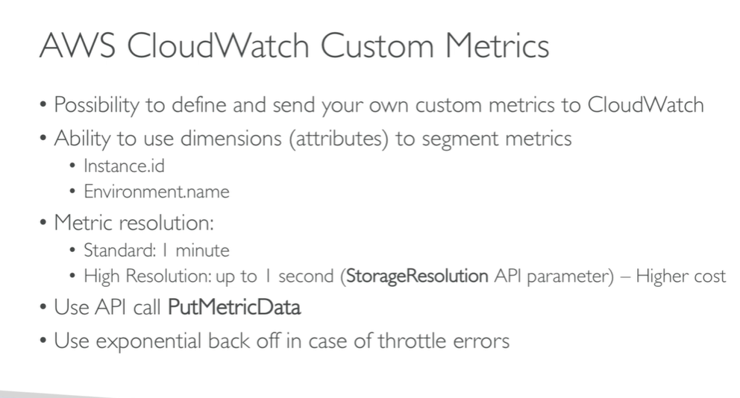

**Cloudwatch metrics hands on**

**Metrics**

**1509 are available**

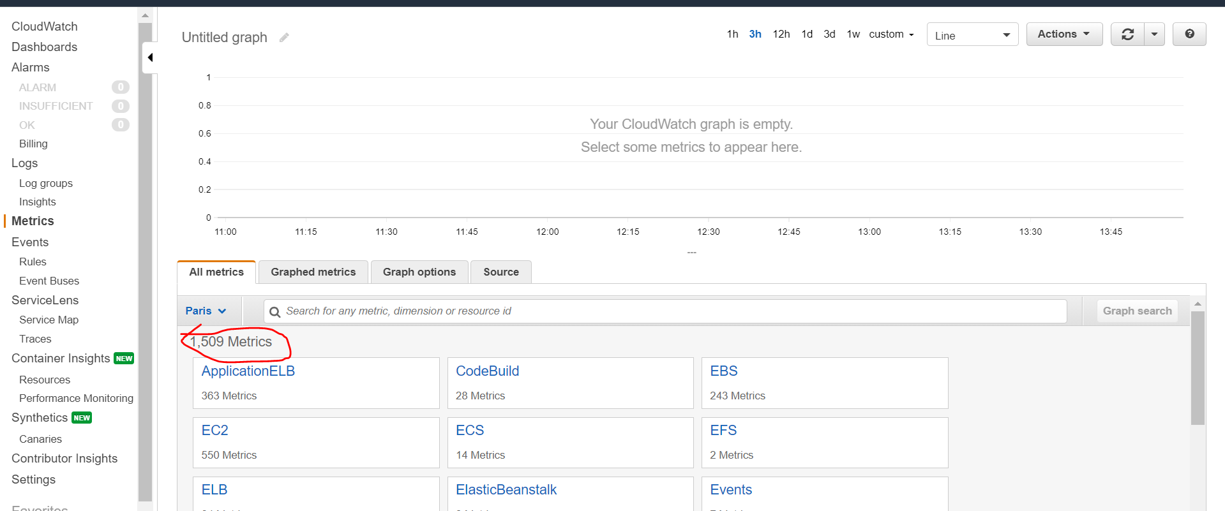

**Cloudwatch/ec2/autpscaling/cpu utilzation we can see graph by hour**

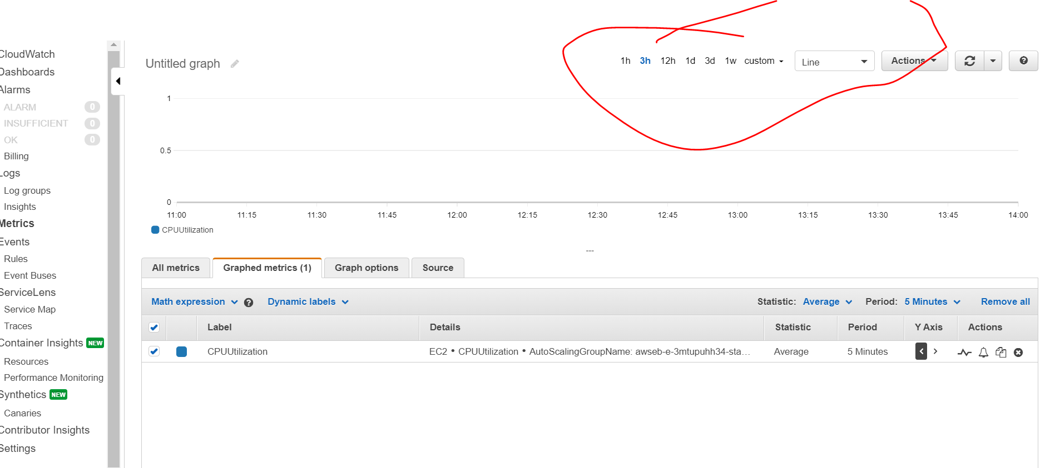

**We can add metrics in dashboard**

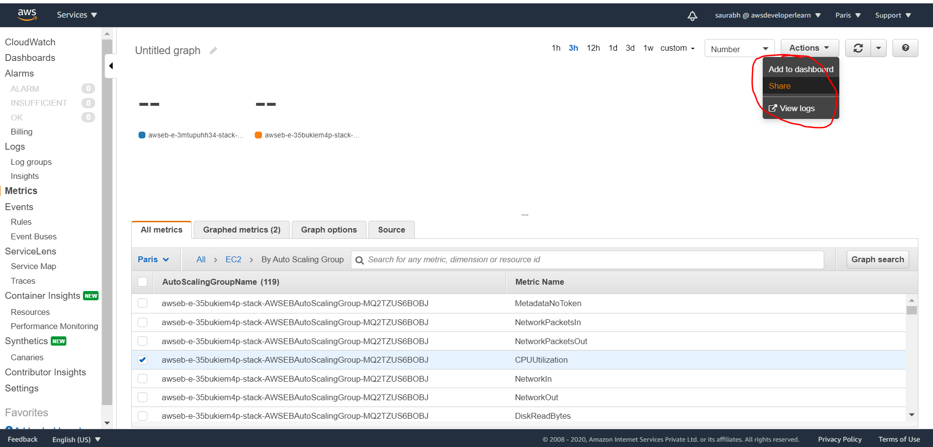

**Click on yes**

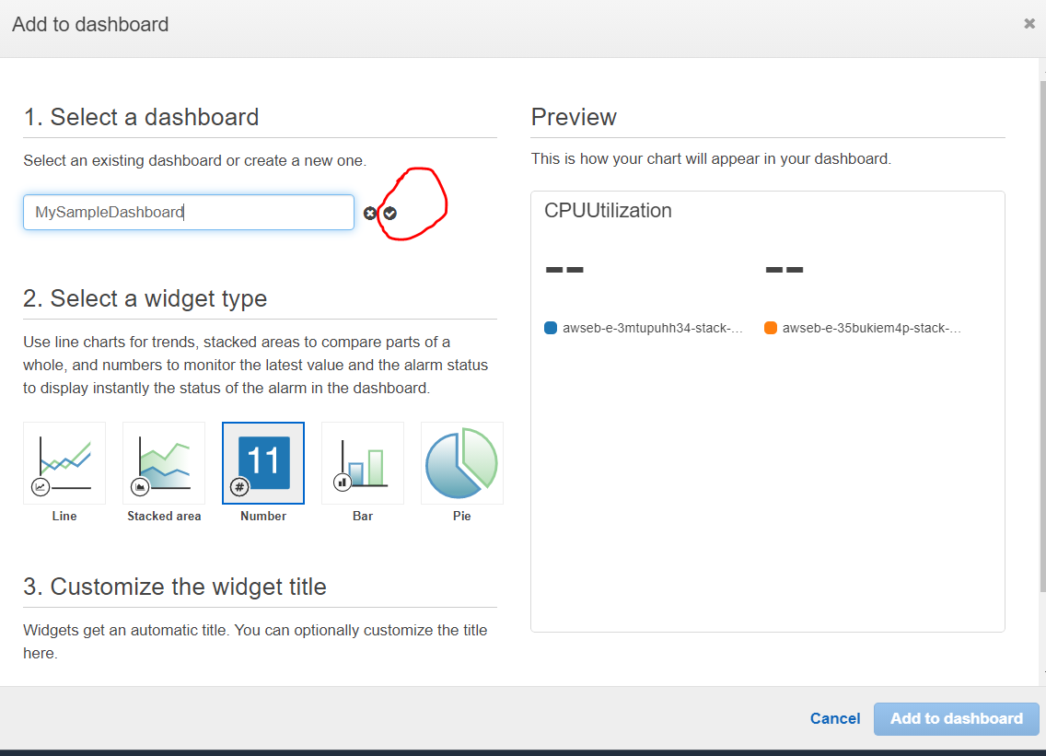

**Mysampledashboard( metric is created as dashboard)**

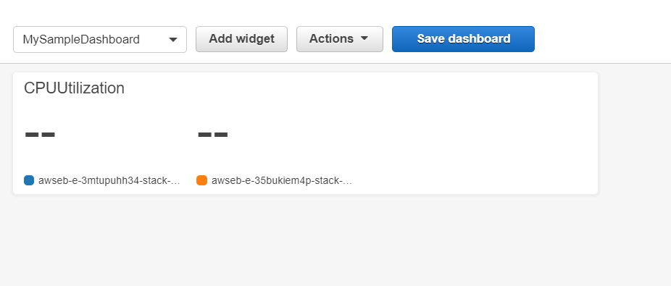

**Note :**

**We can enable metric under monitoring for autoscaling**

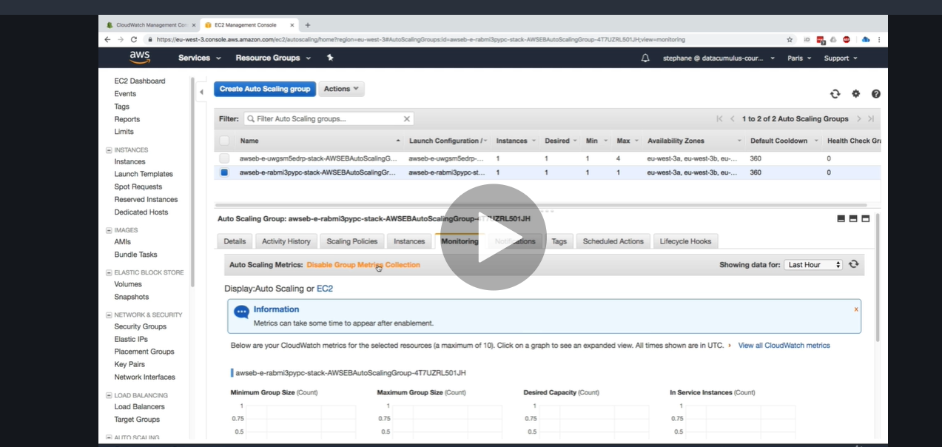

**Note :**

**We can also get metrics for ec2 under monitoring section**

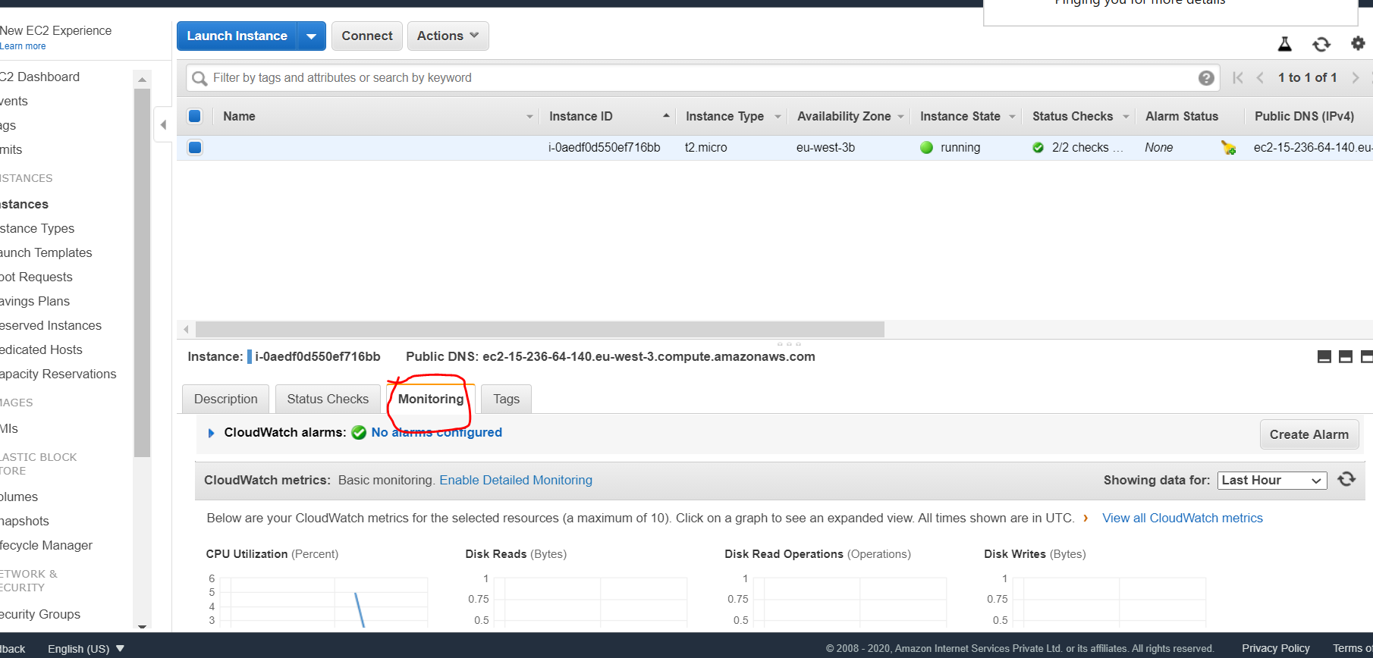

**Note : if we enabled detailed monitoring we will get in every one minute**

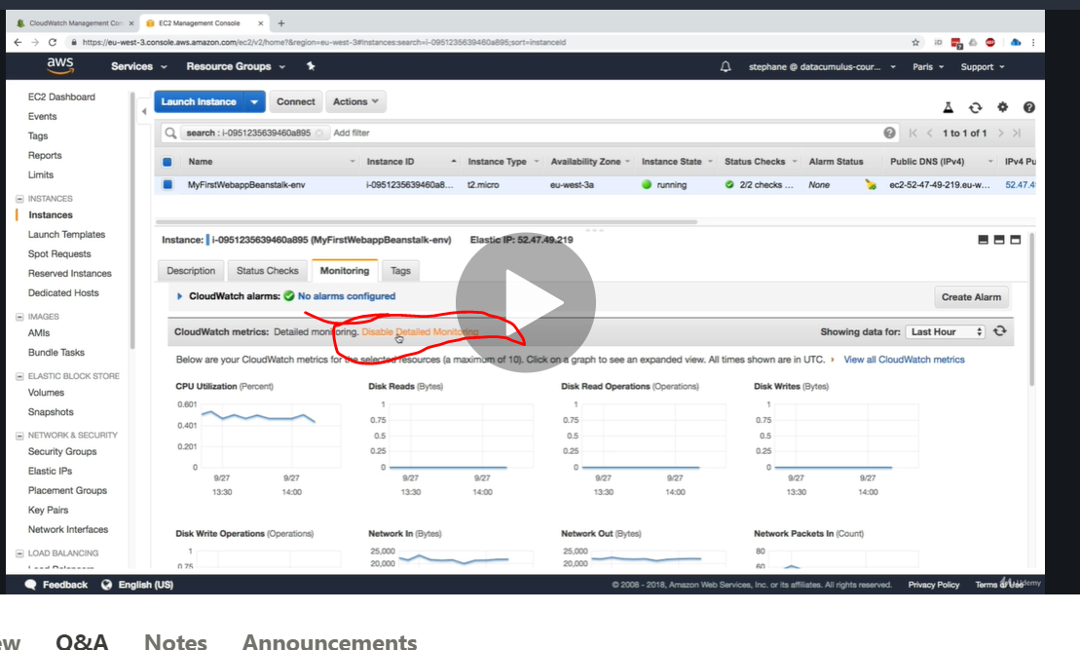

**AWS Cloudwatch Alarms**

The new **CloudWatch Alarms** feature allows you to watch **CloudWatch** metrics and to receive notifications when the metrics fall outside of the levels (high or low thresholds) that you configure.

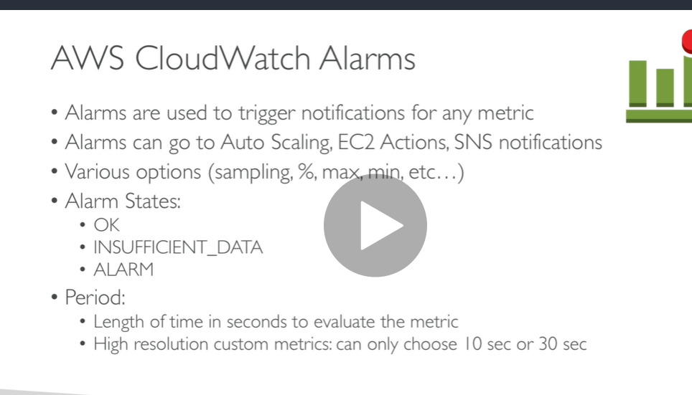

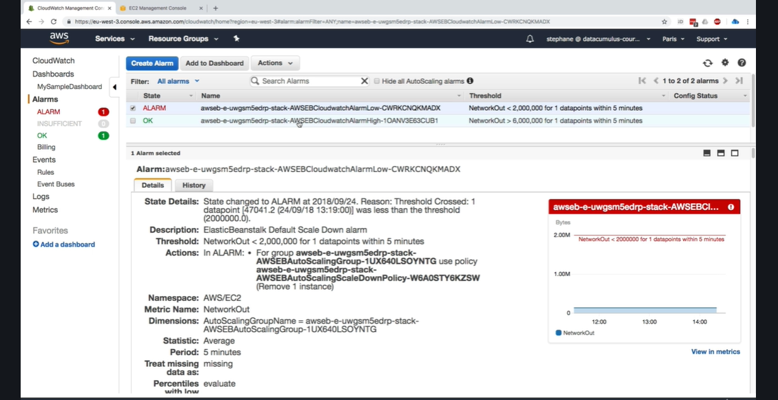

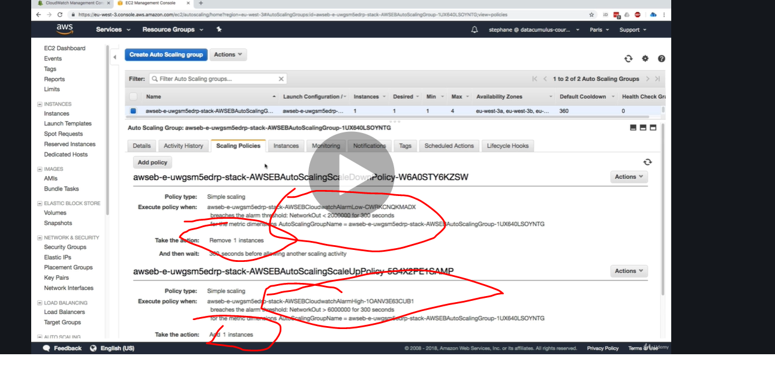

AWS Cloudwatch Logs

We can send logs to cloudwatch

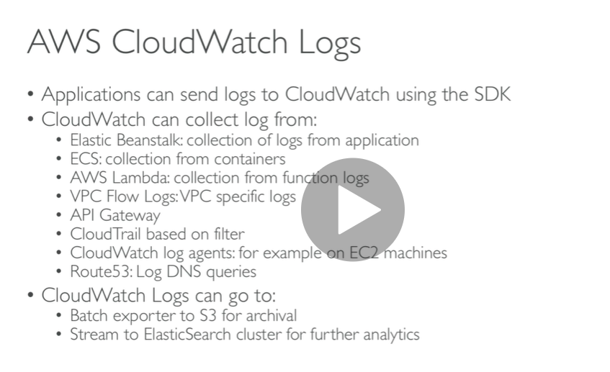

Note :

**To send logs to cloudwatch IAM permission should be correct**

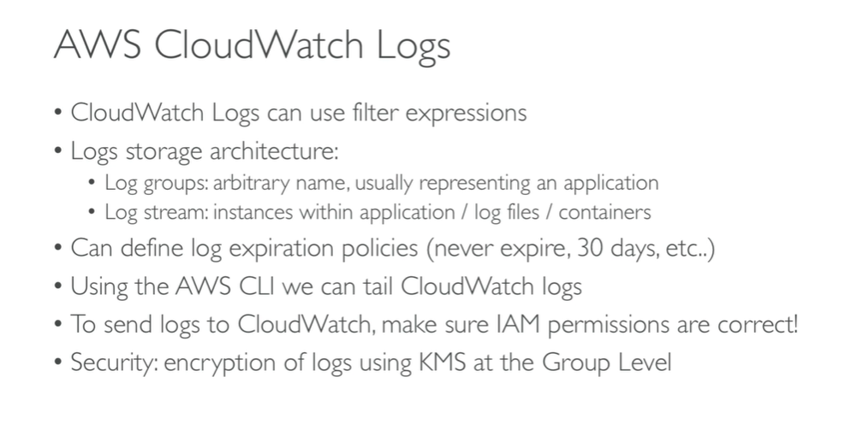

**Hands on**

**Click view logs group**

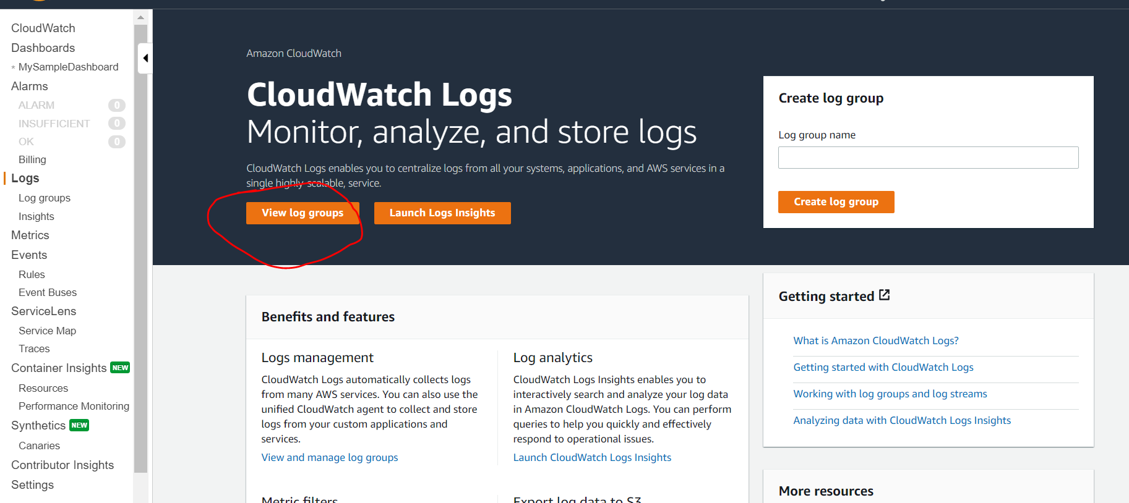

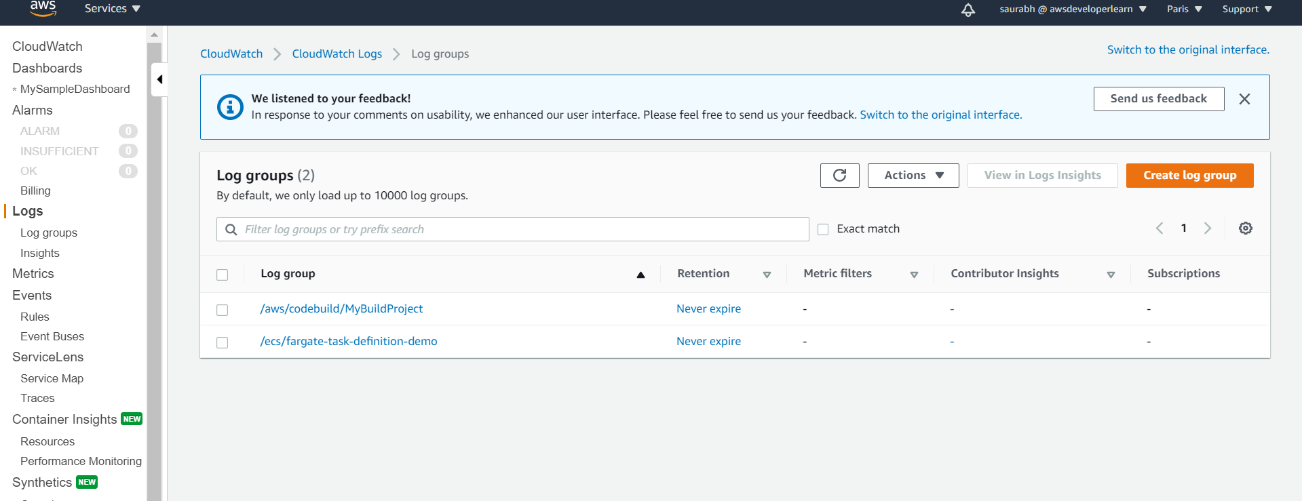

**Code build log is here and we knew we did many build now enter into this**

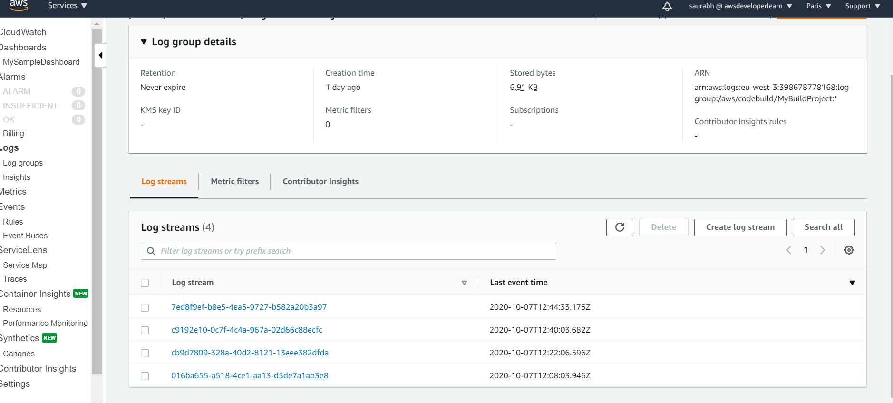

**Note : we can do search all in complete logs**

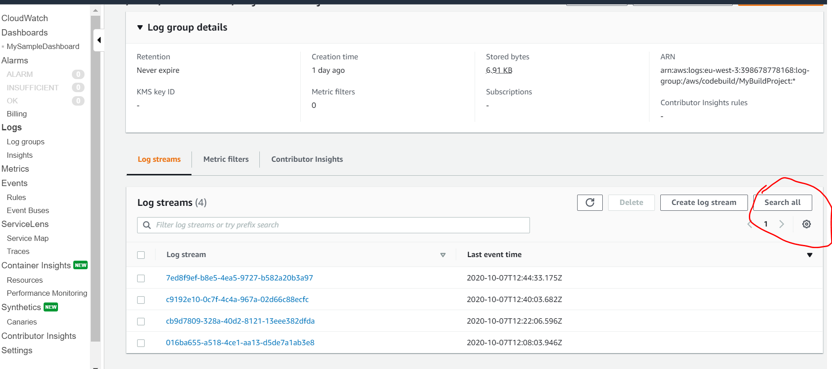

**Note : other thing we can with my cloudwatch logs edit retension setting when does my cloudwatch logs will expire**

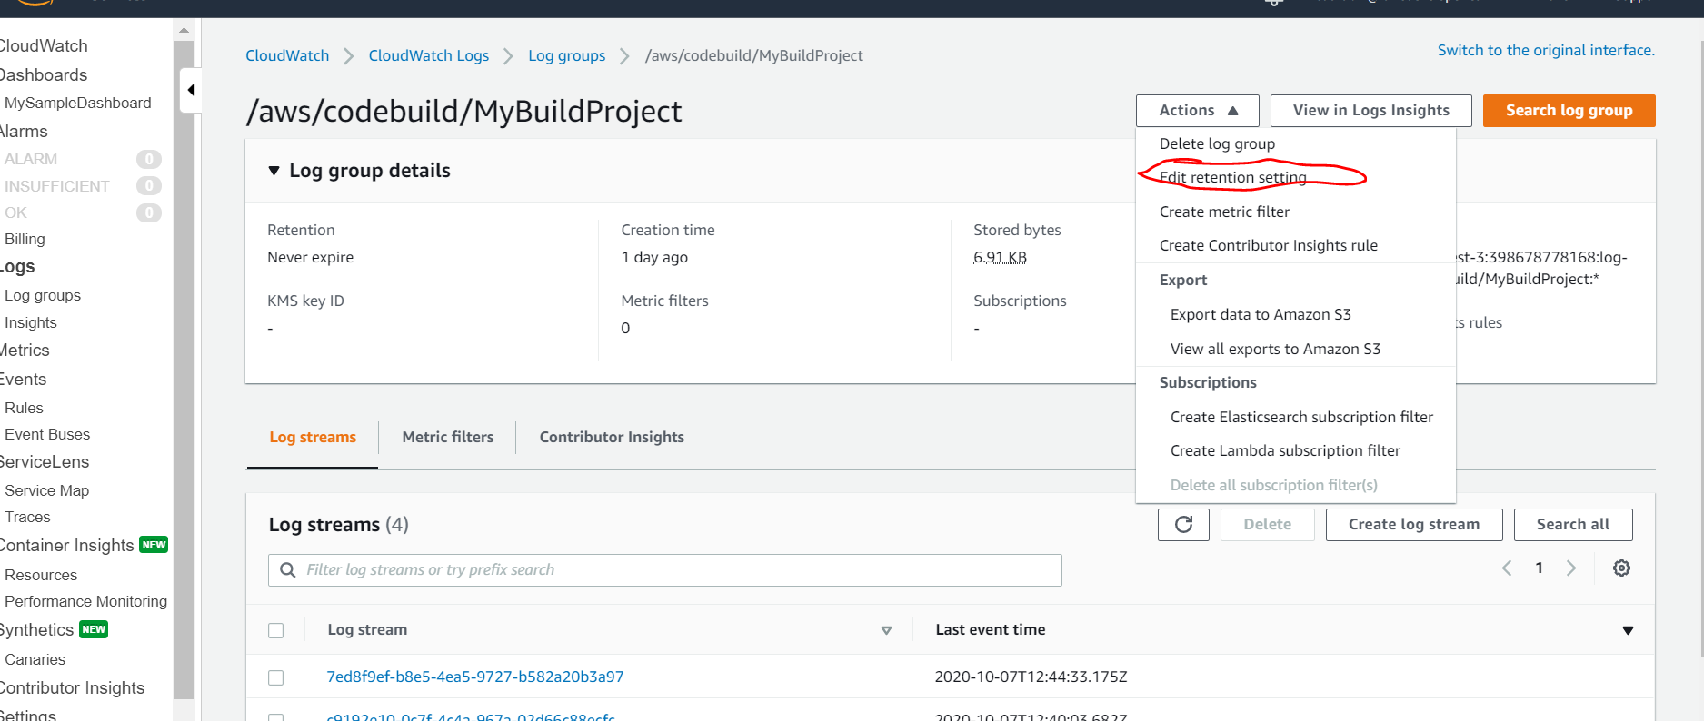

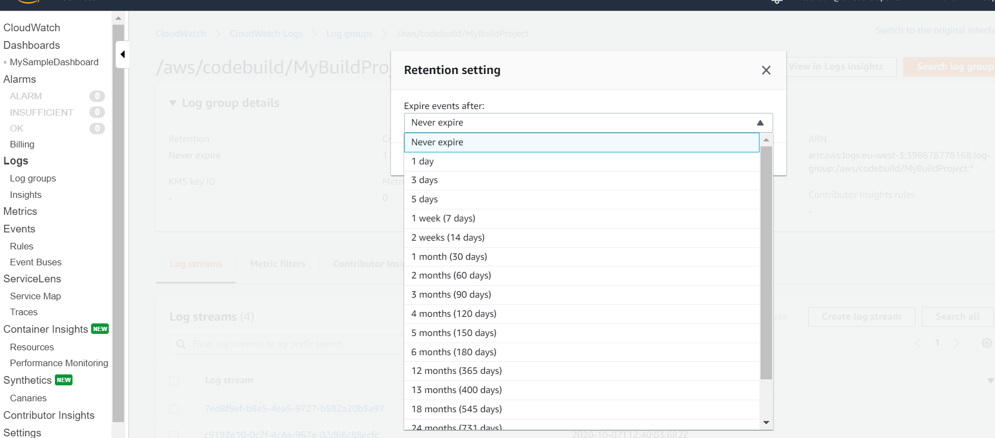

**Note :**

**We can also export data to s3:**

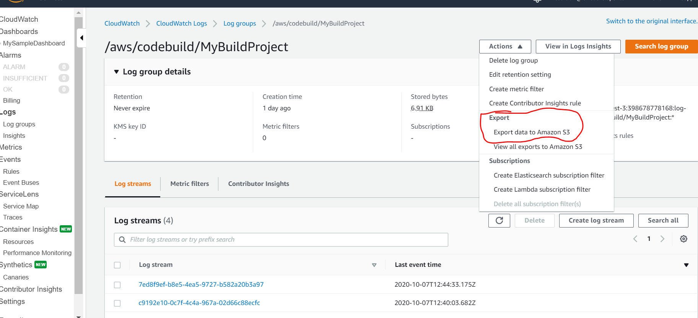

**How to show log from beanstalk to to cloudwatch**

**Click on configuration**

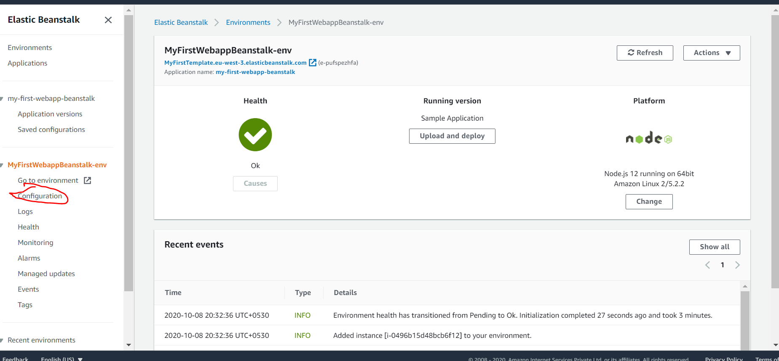

**Click on edit software**

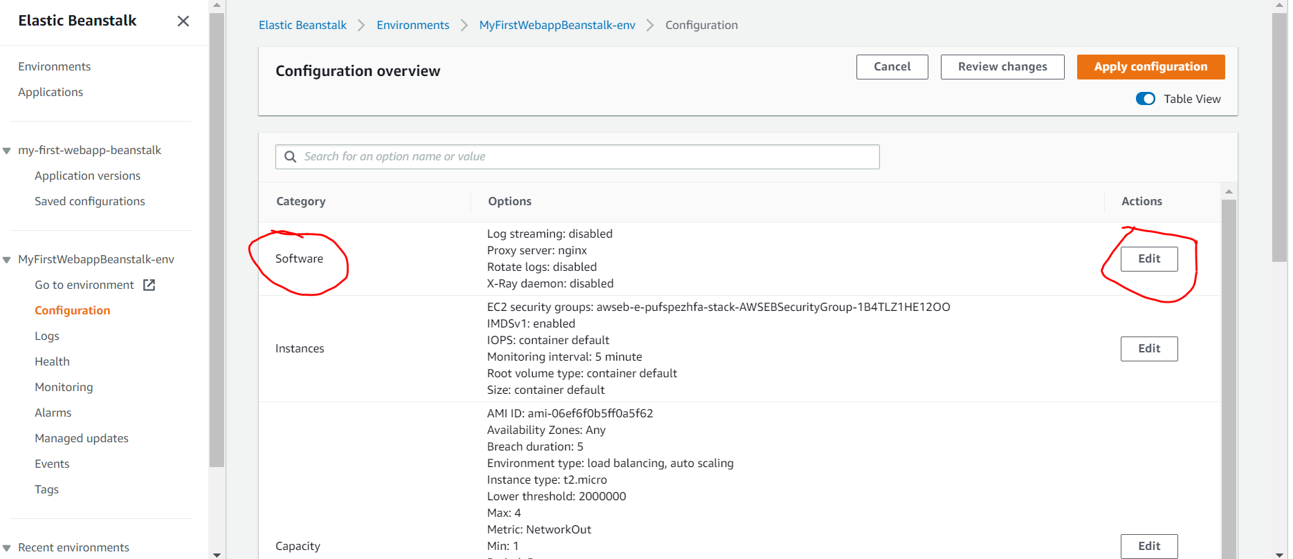

**Click on enabled logs will show in cloudwatch**

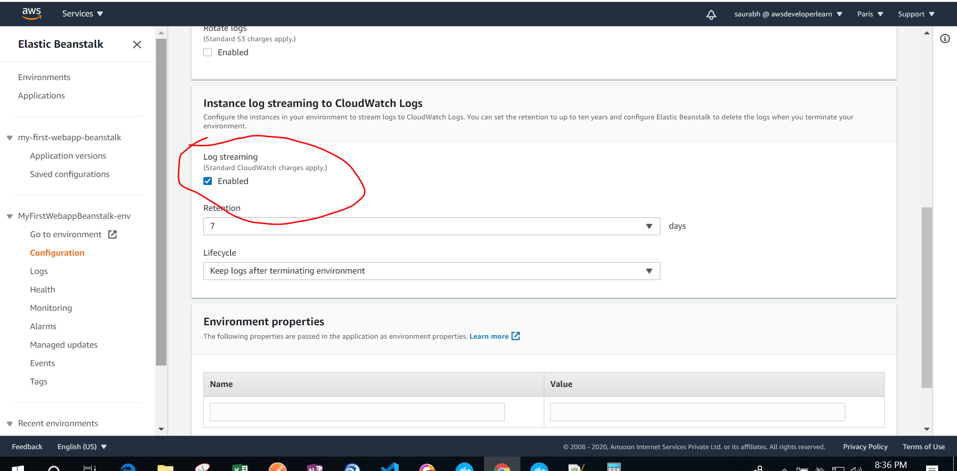

**Another way we can do just go to monitoring and enabled cloudwatch**

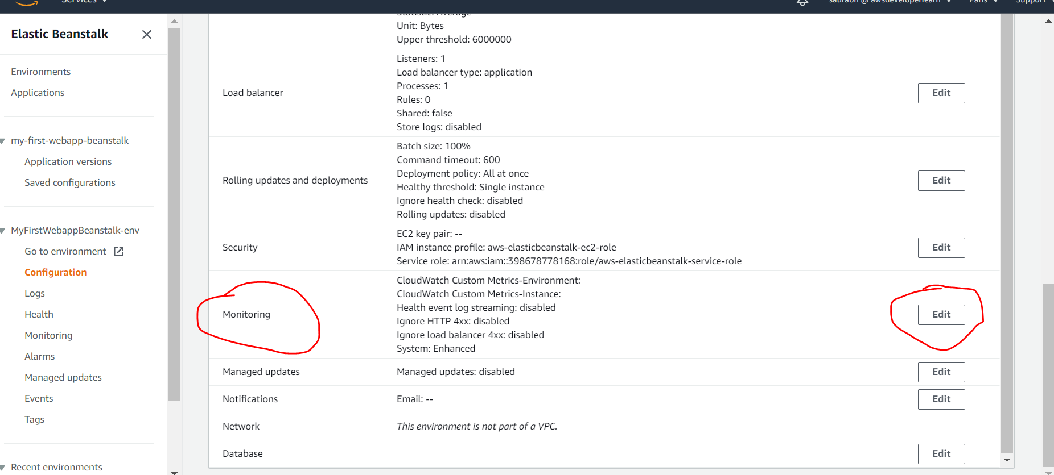

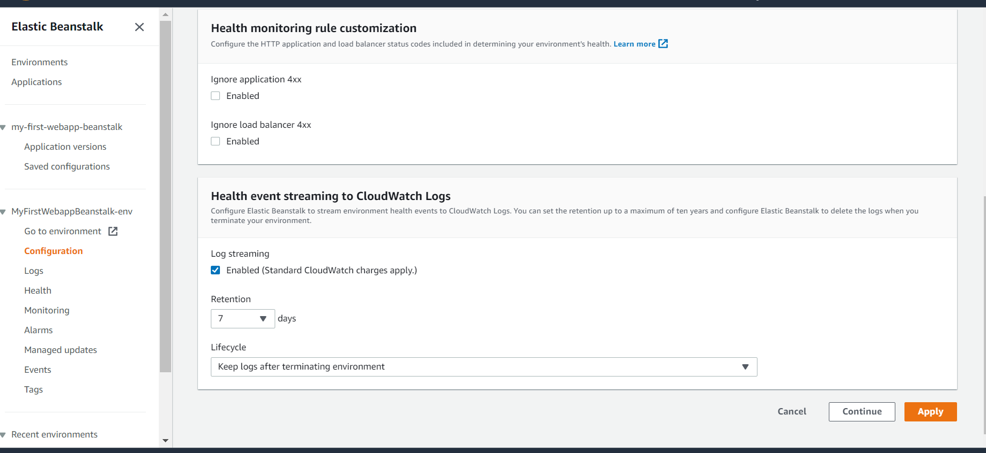

**Note : now we will get logs in cloudwatch**

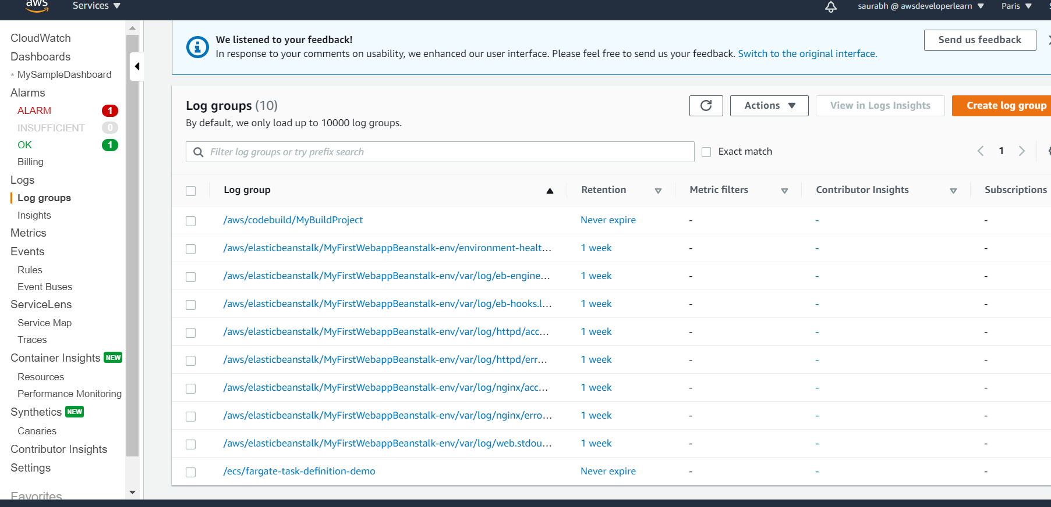

**Cloudwatch agent and cloudwatch logs agent**

**Note : by default no logs go from ec2 instance to clouwatch**

**Note : cloudwatch log agent must be run in ec2 and for this ec2 instance must have iam role to send logs to cloudwatch**

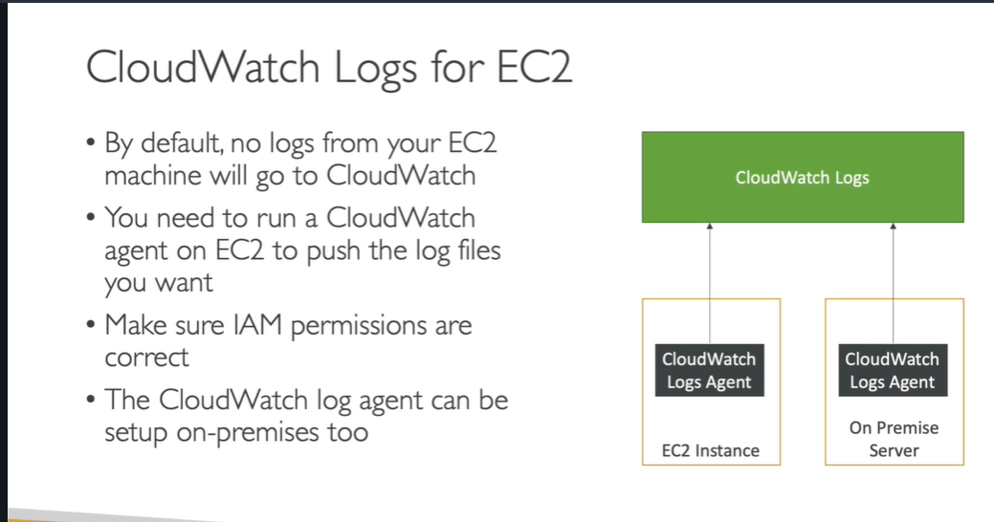

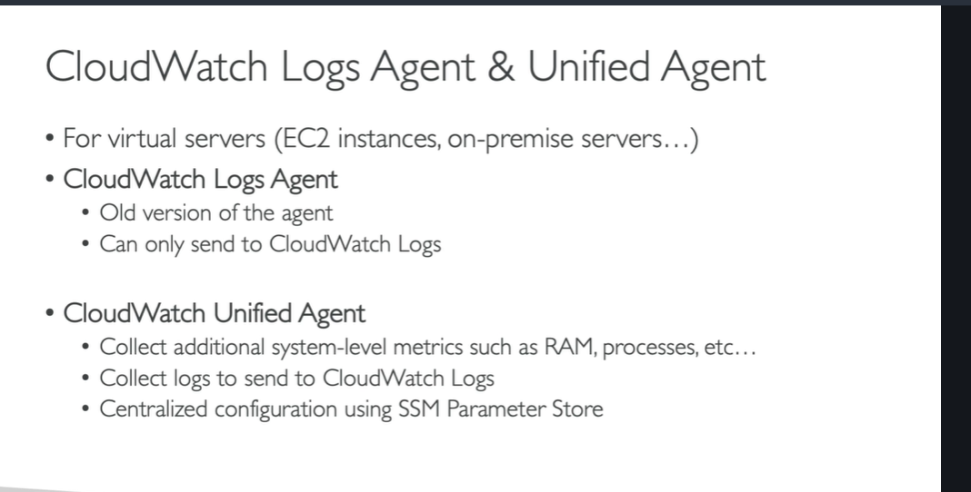

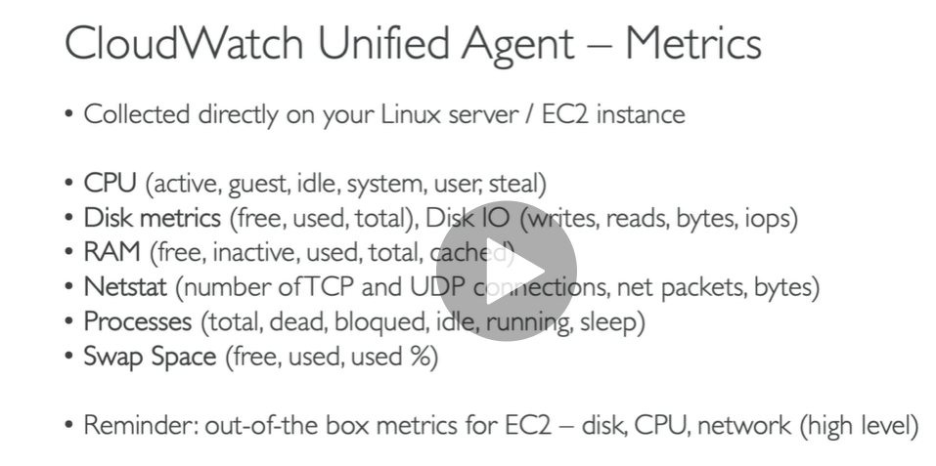

**Cloudwatch logs metrics filter**

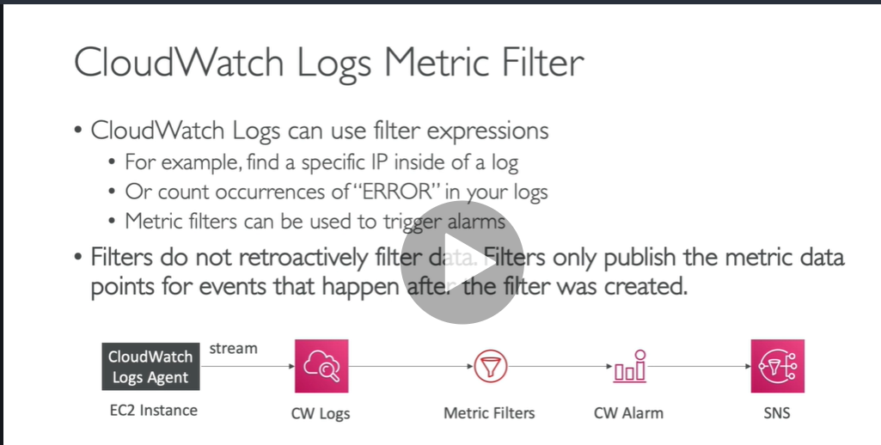

**Hands on**

**Click nginx access logs**

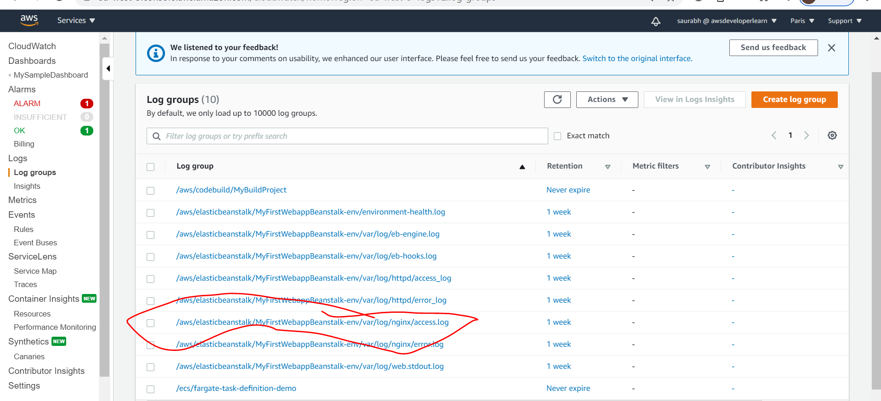

**Requirement:**

**To create a metric filter on log stream**

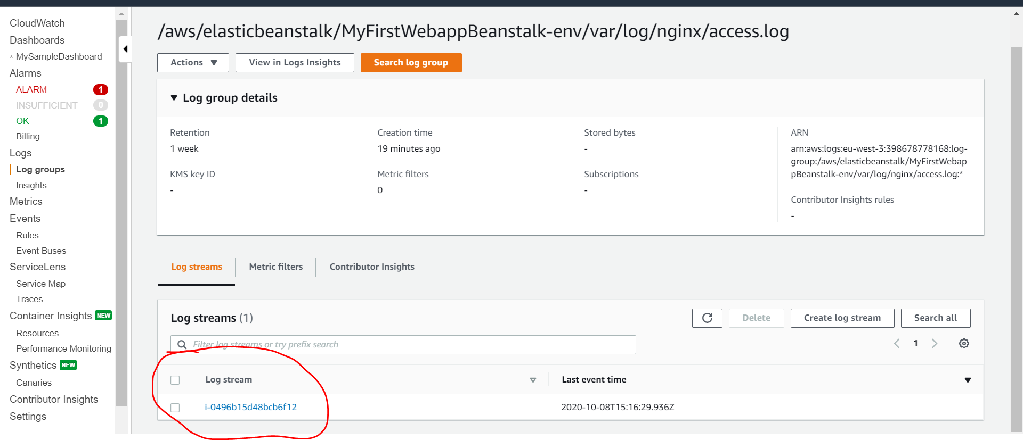

**Create metric filter**

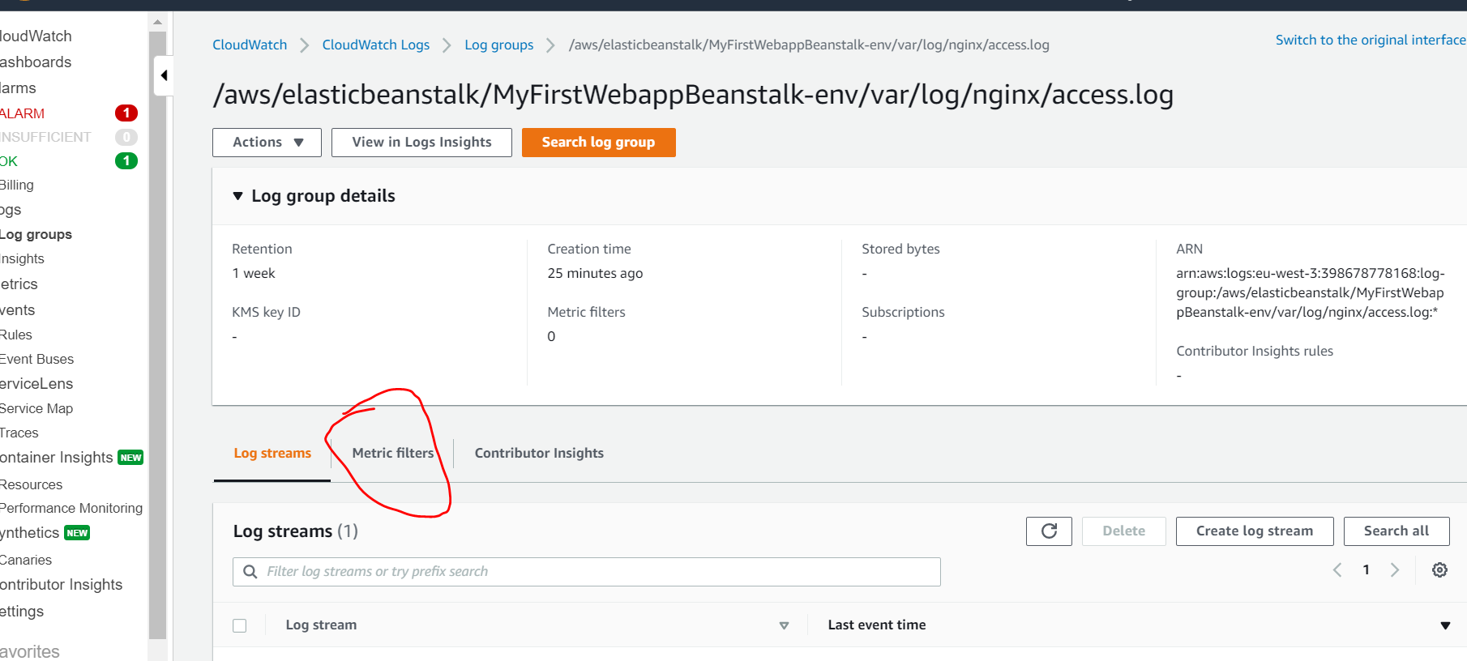

**Filter by pattern we will get result**

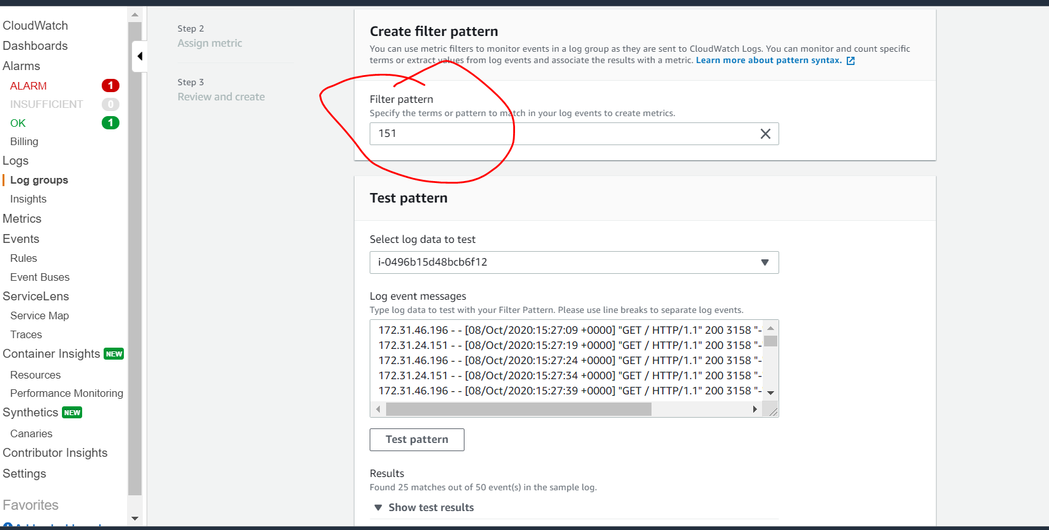

**Click next**

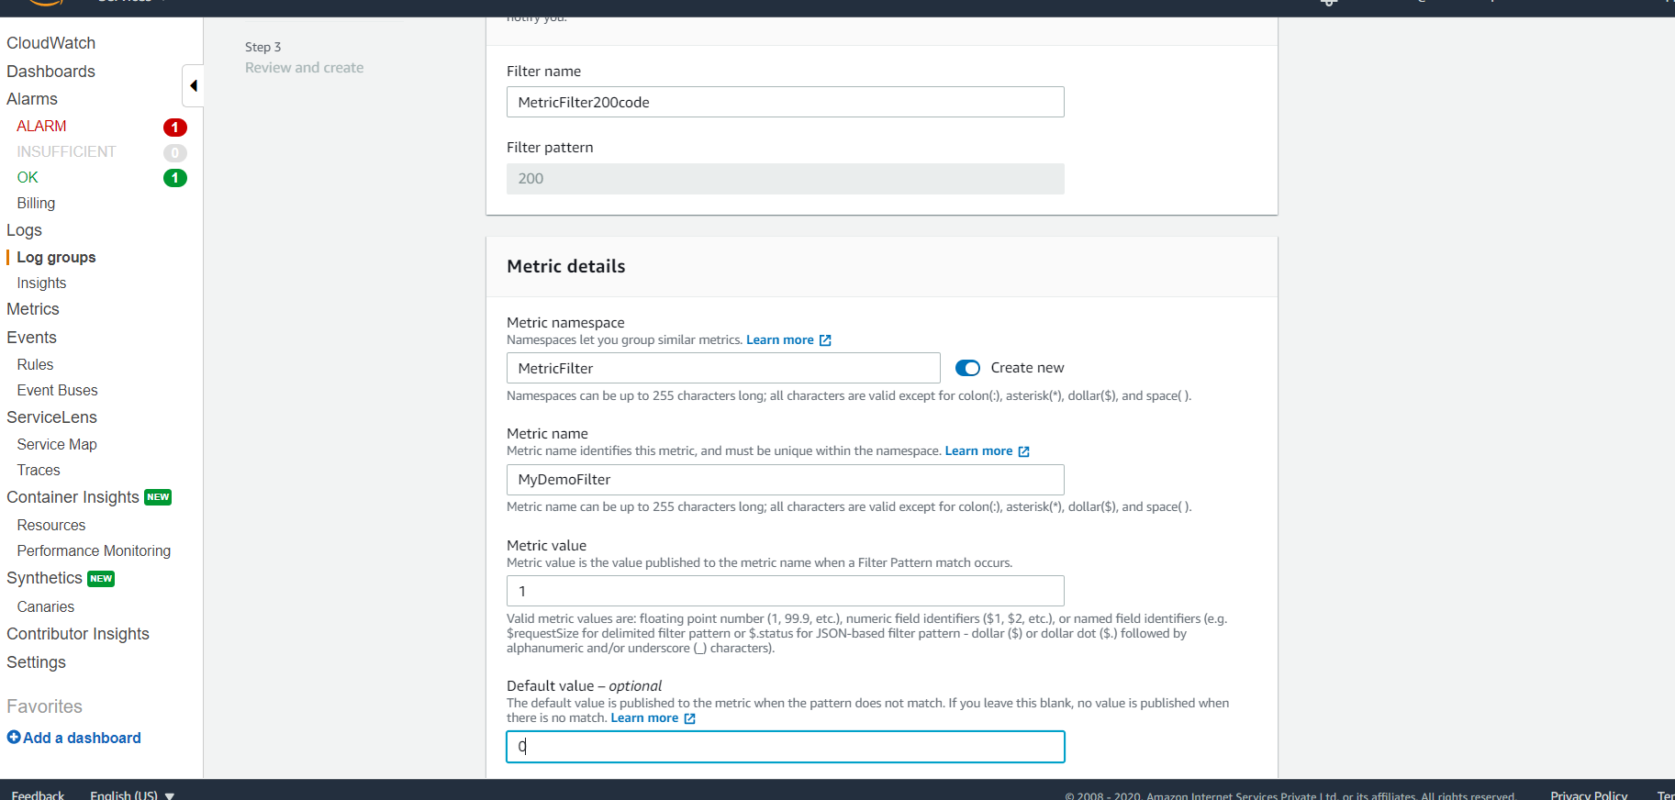

**Now metric filter has been created**

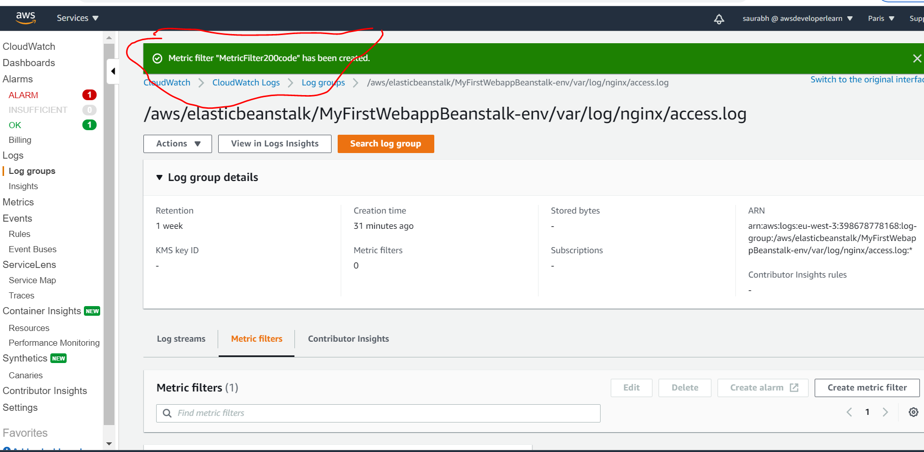

**Click restart app server**

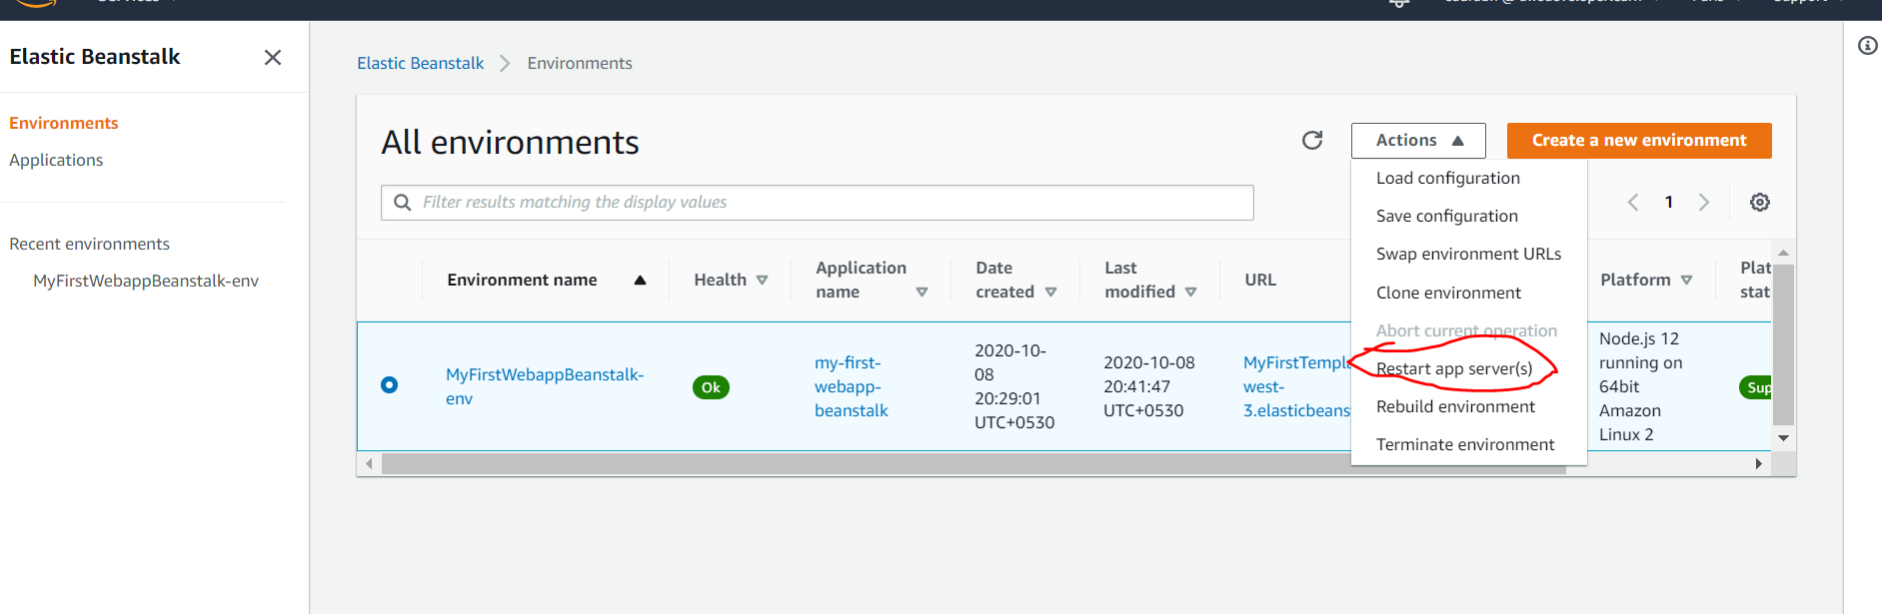

**This will add more logs**

**Another thing we can do with metric filter click on it then we can create alarm**

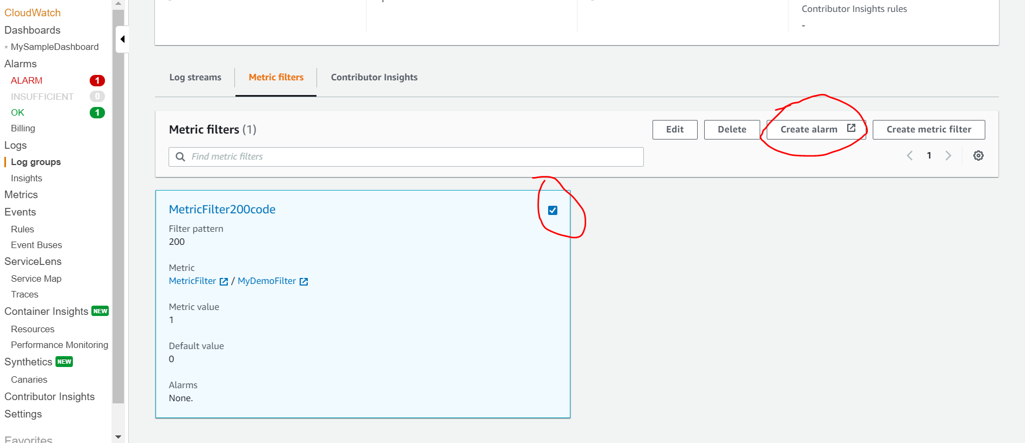

**We can create alarm on top of metric filter( filter data in logs )log coming from cloudwatch**

**If some alram raise it will send message to SNS**

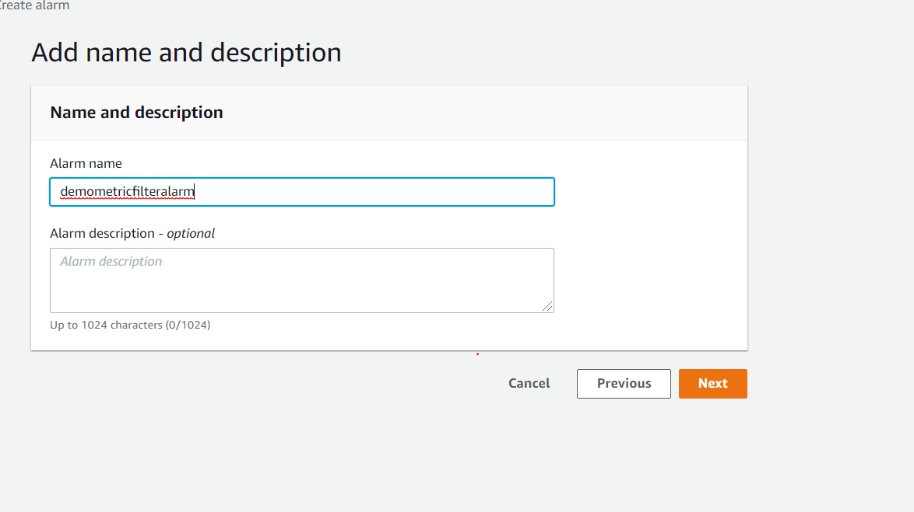

**Now alarm is linked to metric filter**

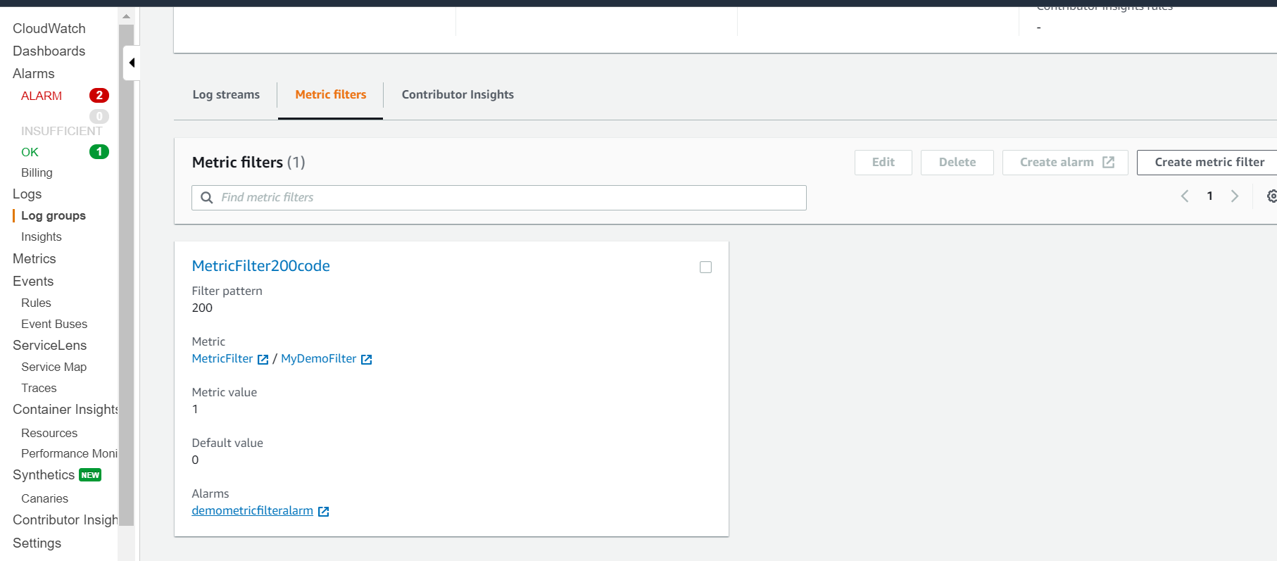

**AWS Cloudwatch events**

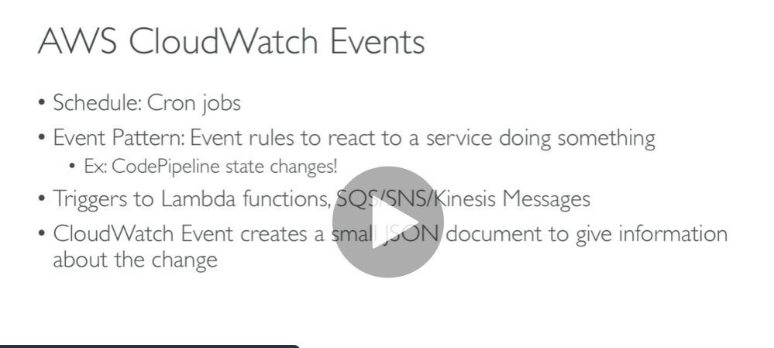

**Demo**

**Click events**

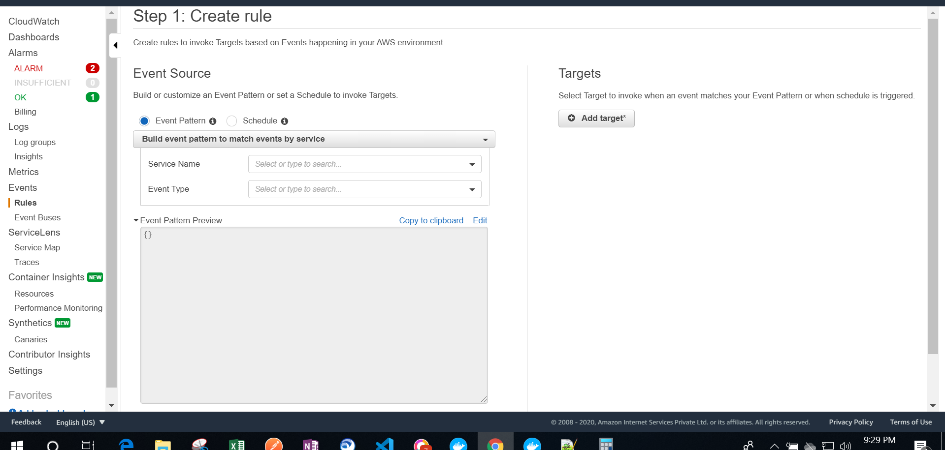

**Any time my pipeline failed alarm trigger and write to SNS**

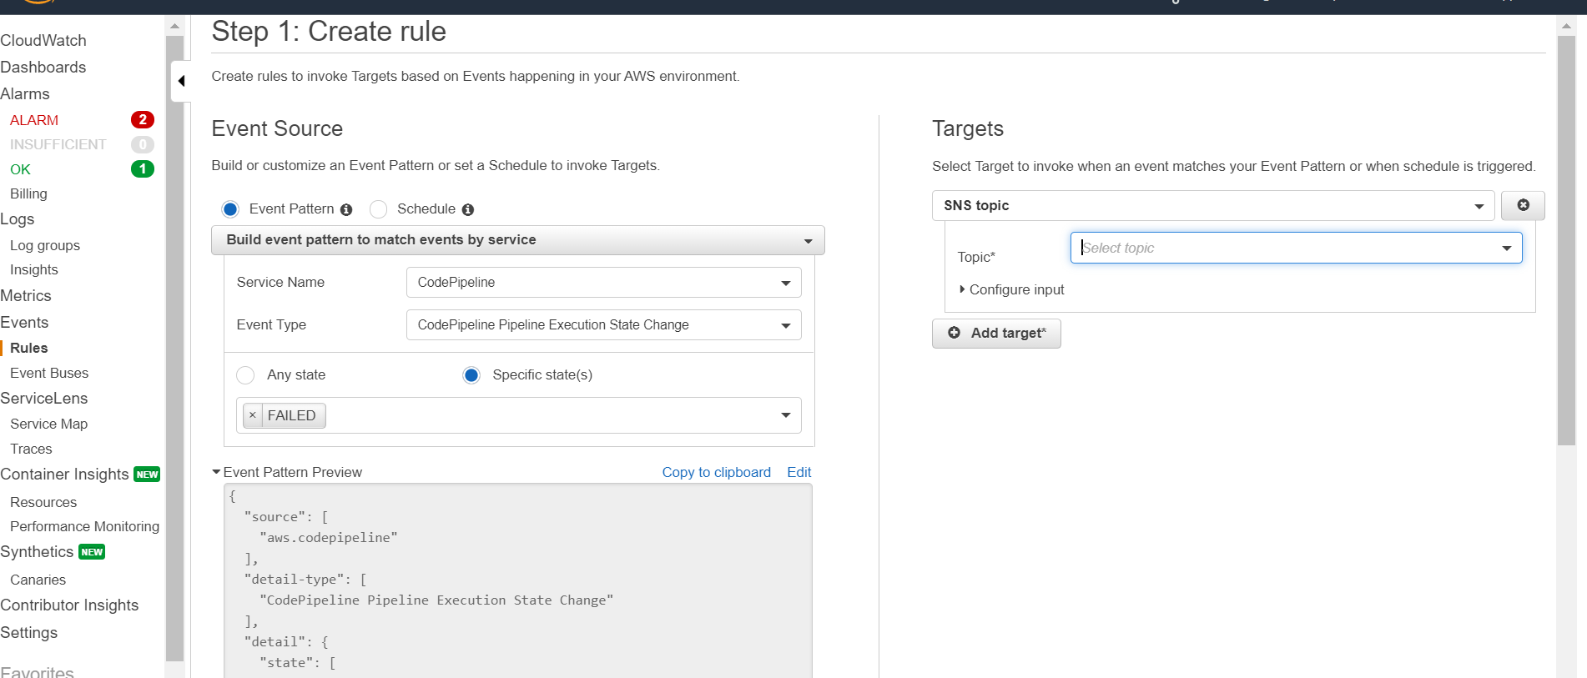

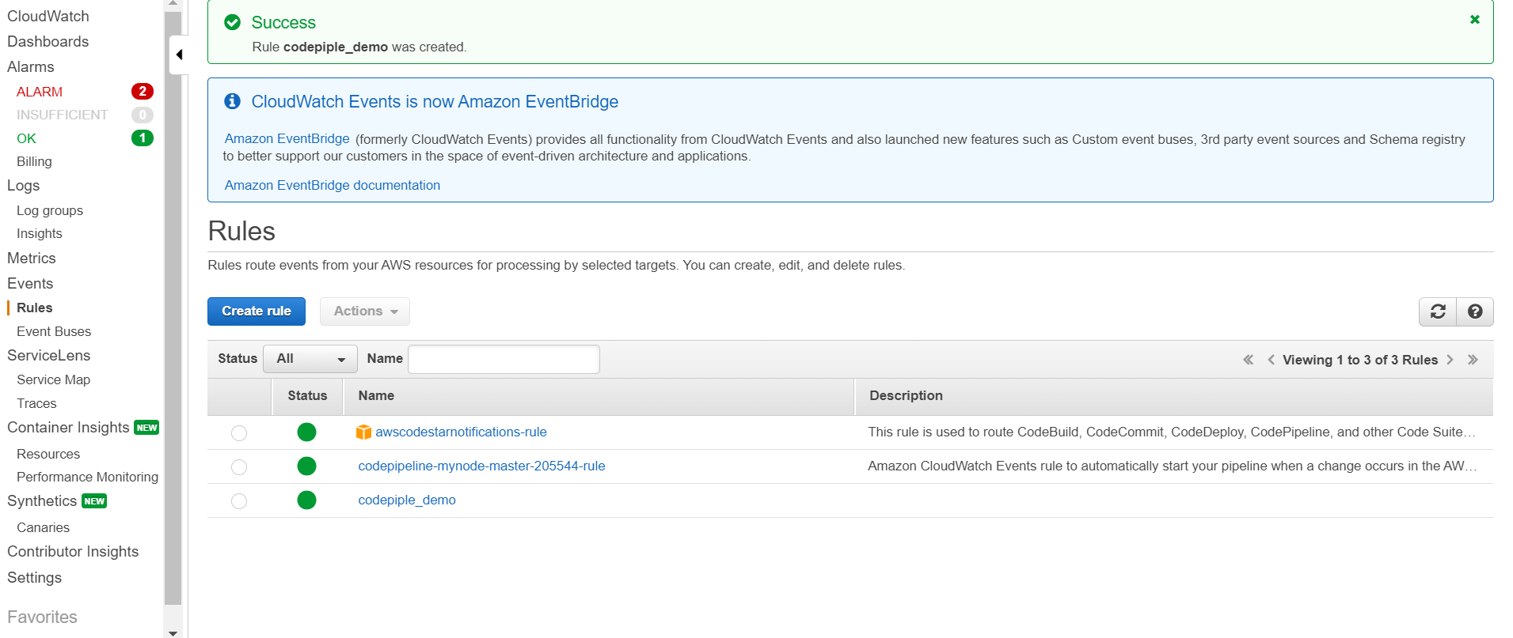

**Amazon Event bridge**

**Other parties can send event to aws account**

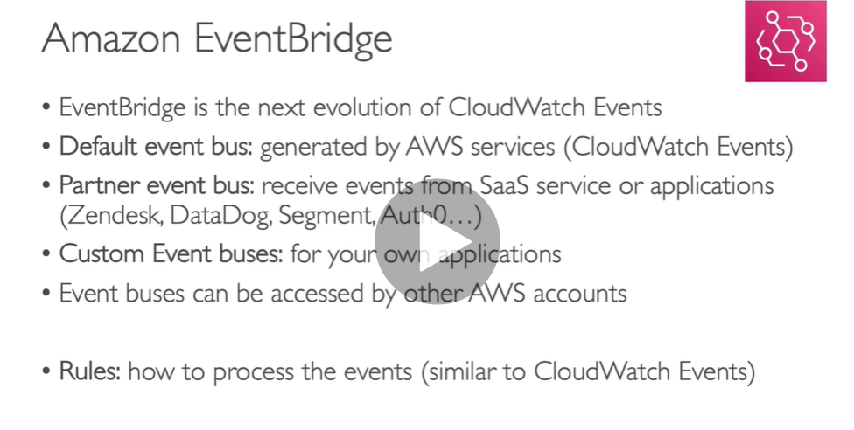

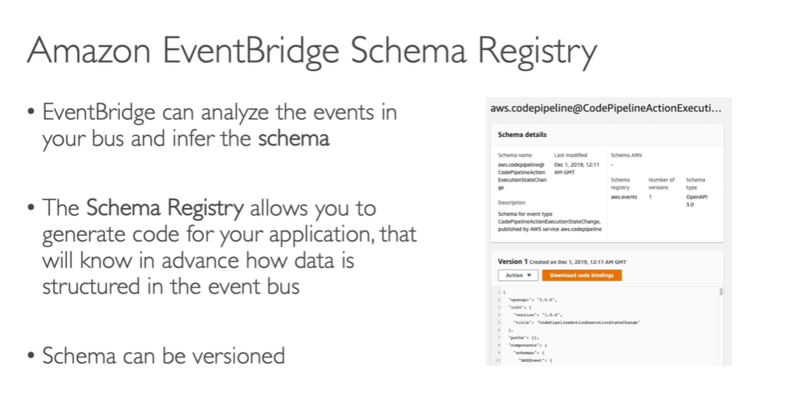

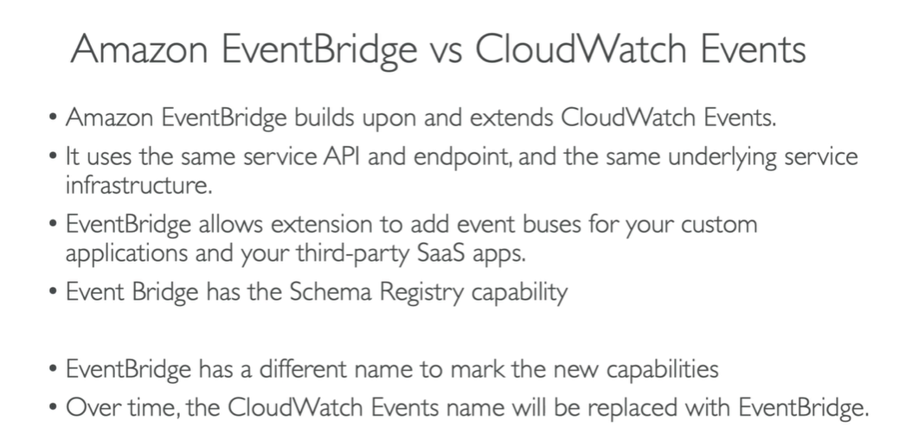

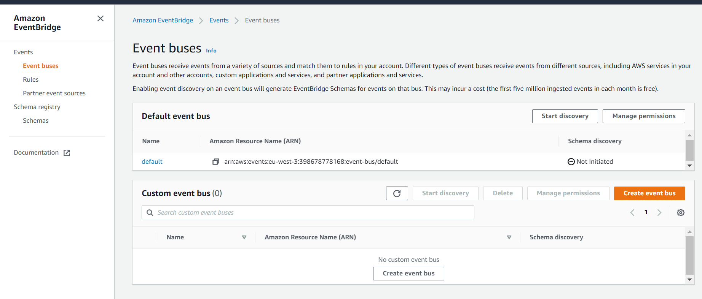

**Currently 31 partner event**

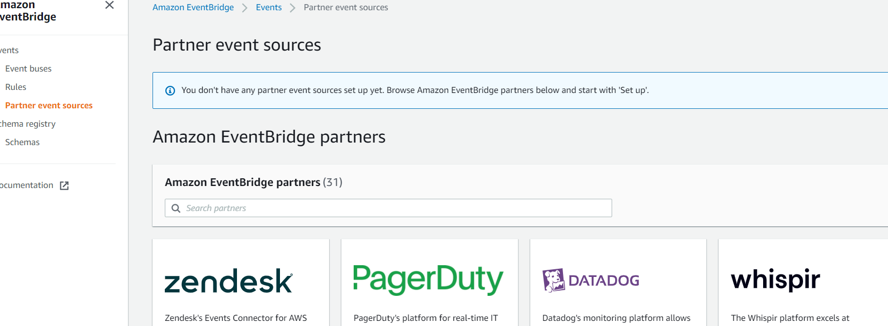

**For each partner we can set up instruction**

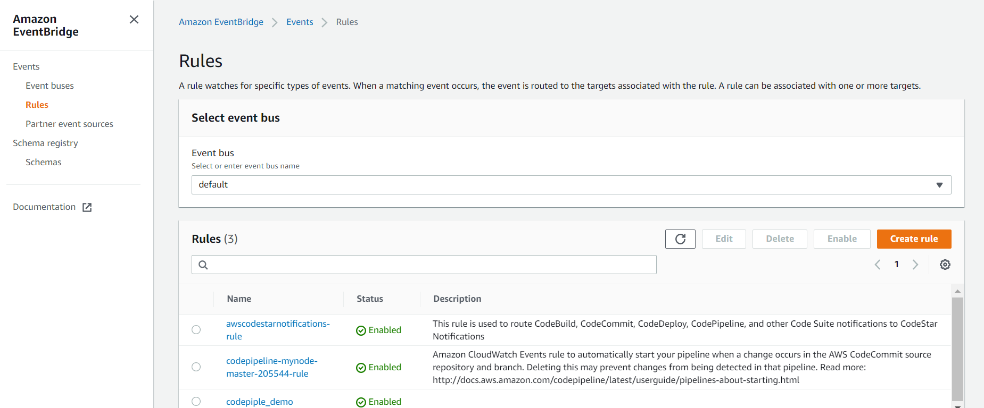

**Aws xray**

**AWS X-Ray** helps developers analyze and debug production, distributed applications, such as those built using a microservices architecture. ... **X-Ray** provides an end-to-end view of requests as they travel through your application, and shows a map of your application's underlying components.

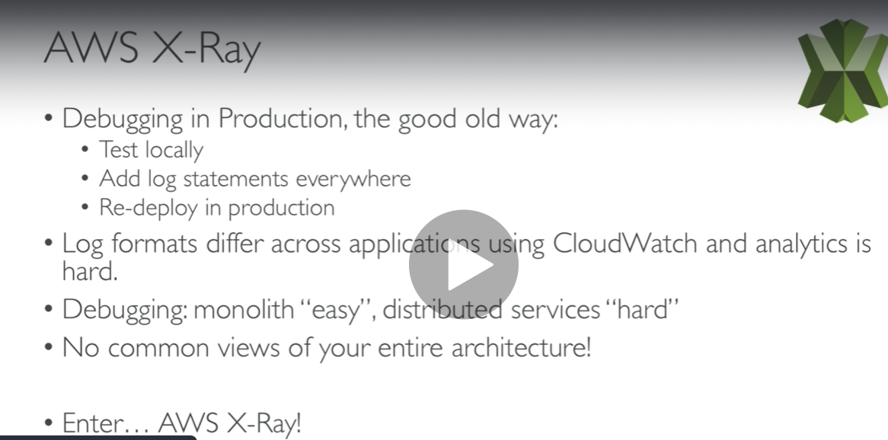

**Error is coming from dynamo db table that we can visualise it using x ray**

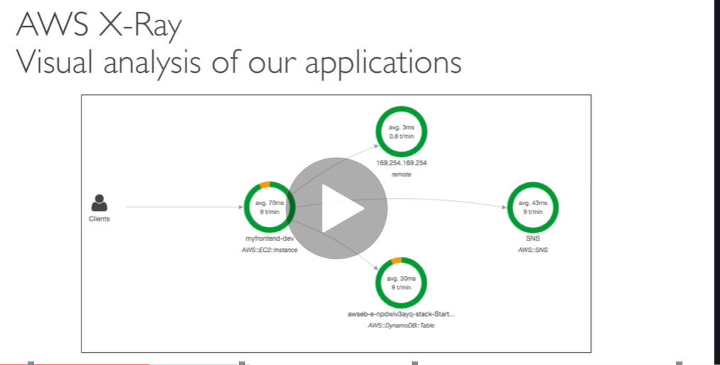

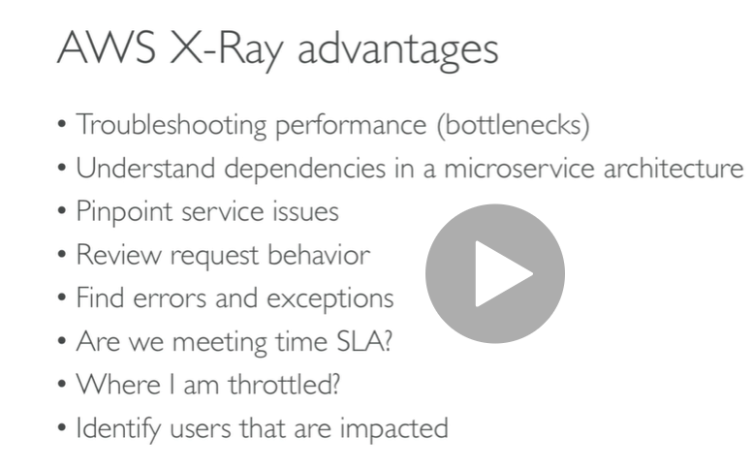

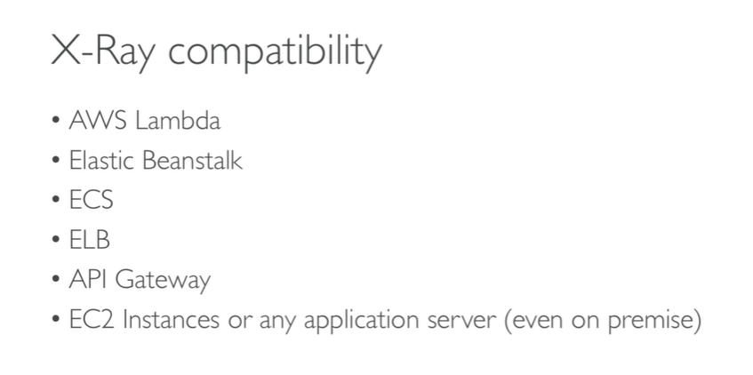

**Note : each service will add it own trace**

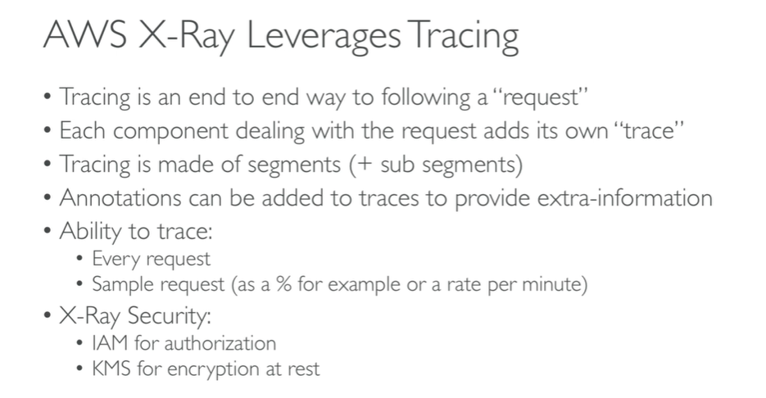

**How to enable x rays:**

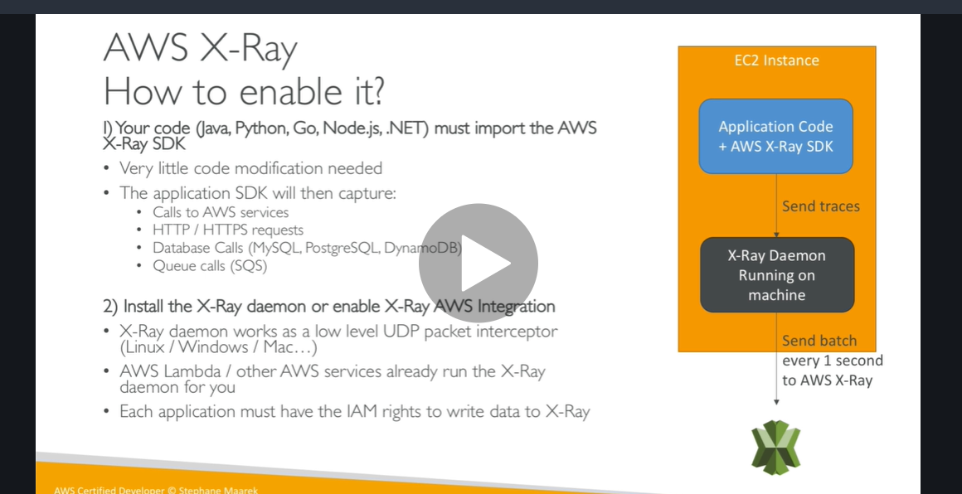

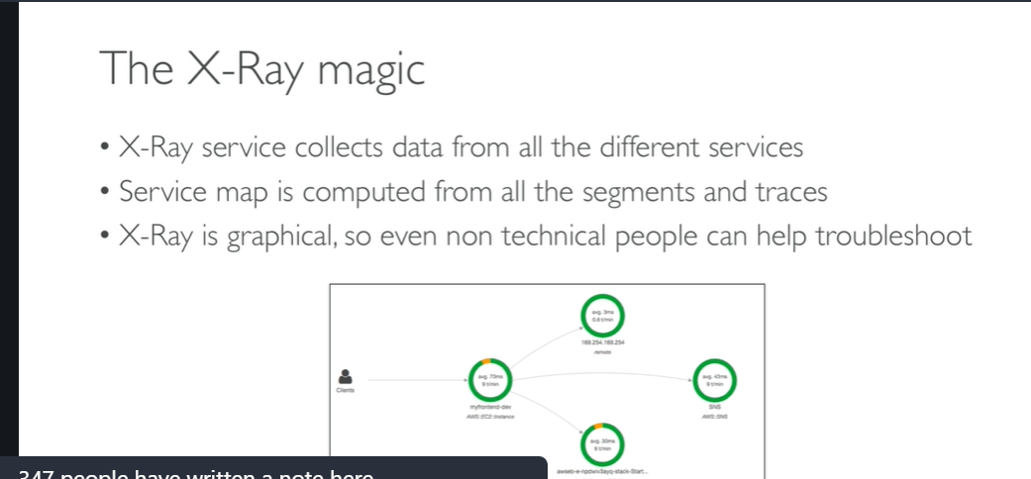

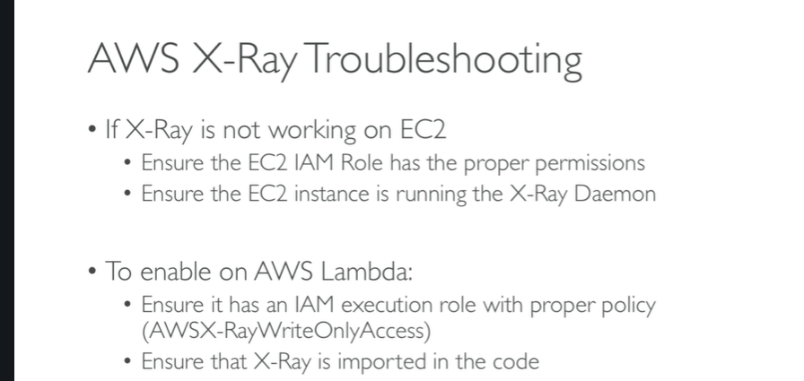

**Xrays hands on**

**Type xray**

**Click on get started**

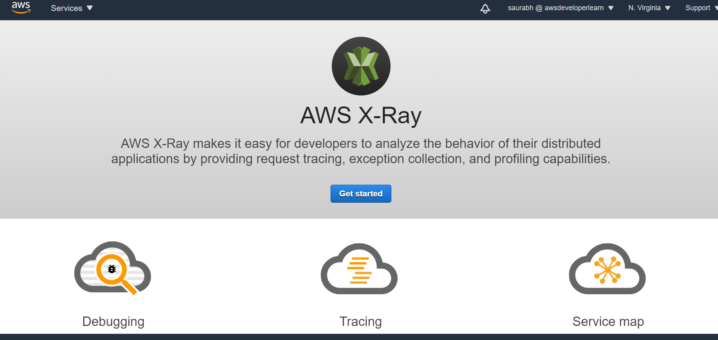

**Read xray daemon**

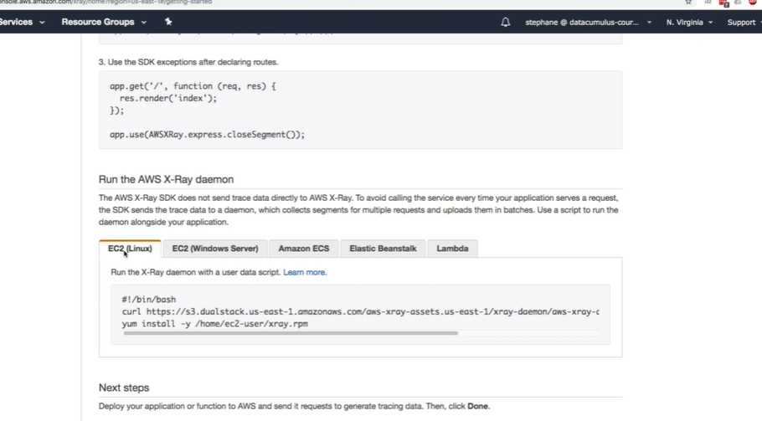

**We can enabled xrays in elastic beanstalk by adding below lines at root level**

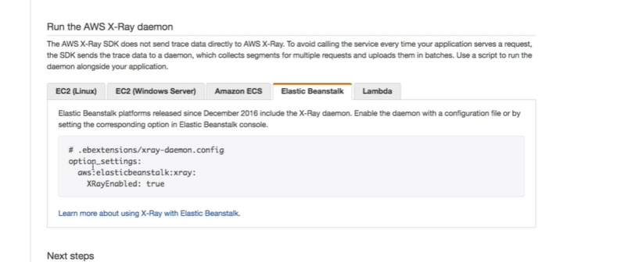

**Step 1) ( xrays didn’t do hands on)**

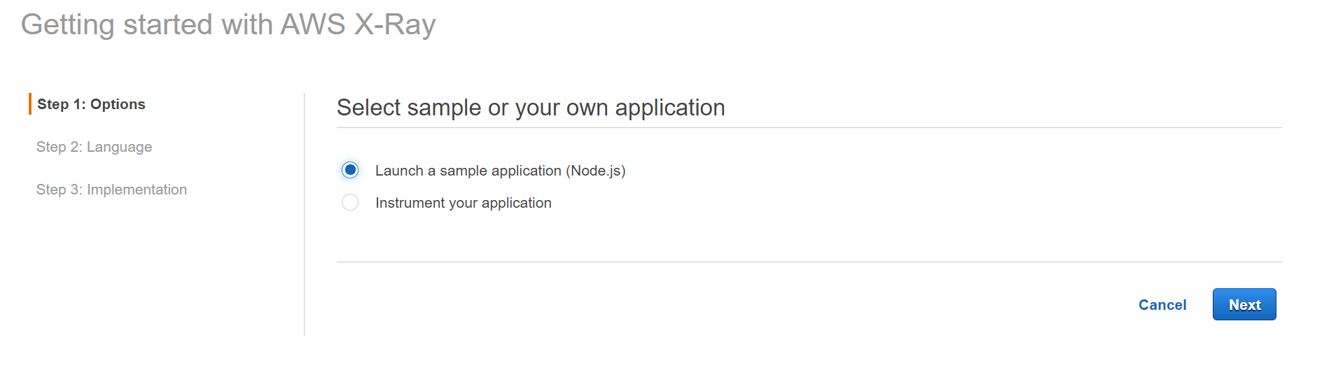

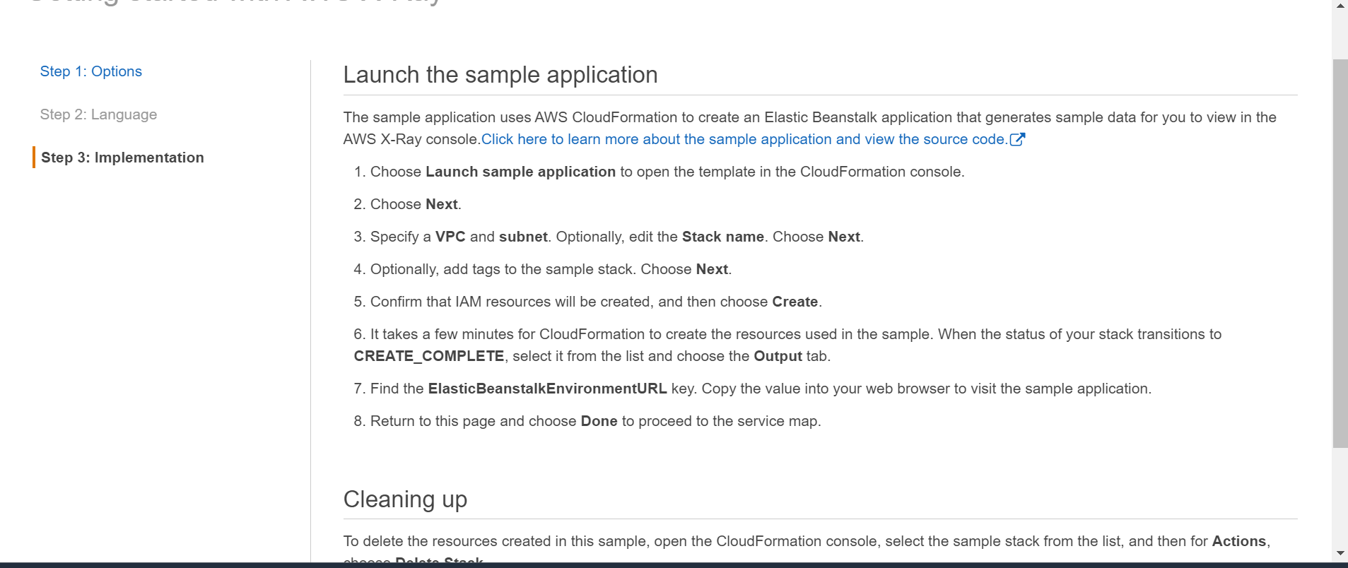

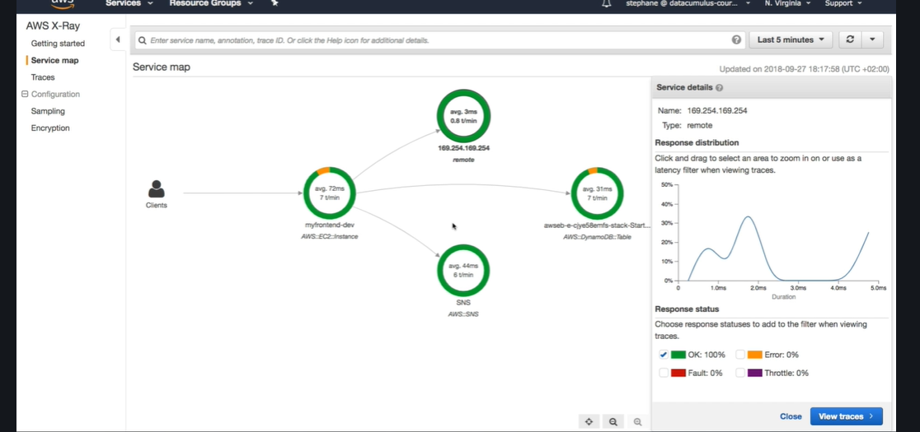

**Xrays instrumentation and concept**

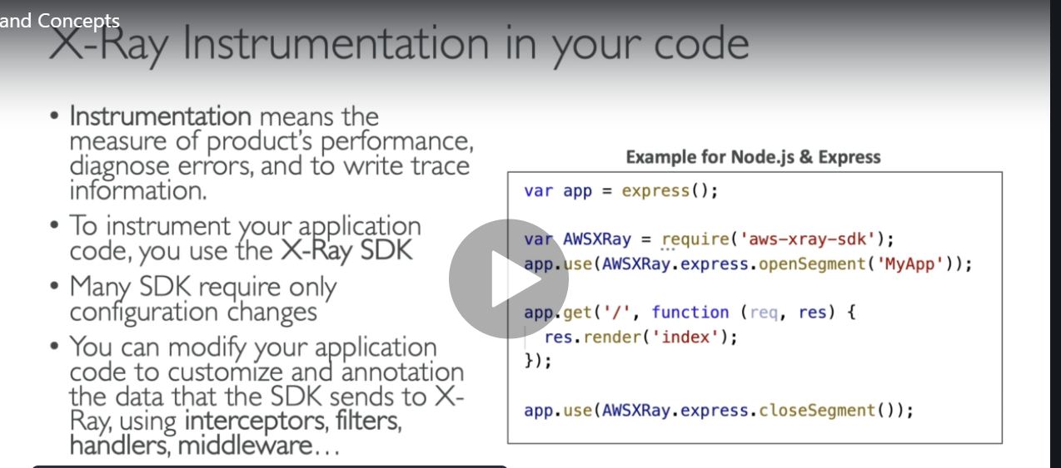

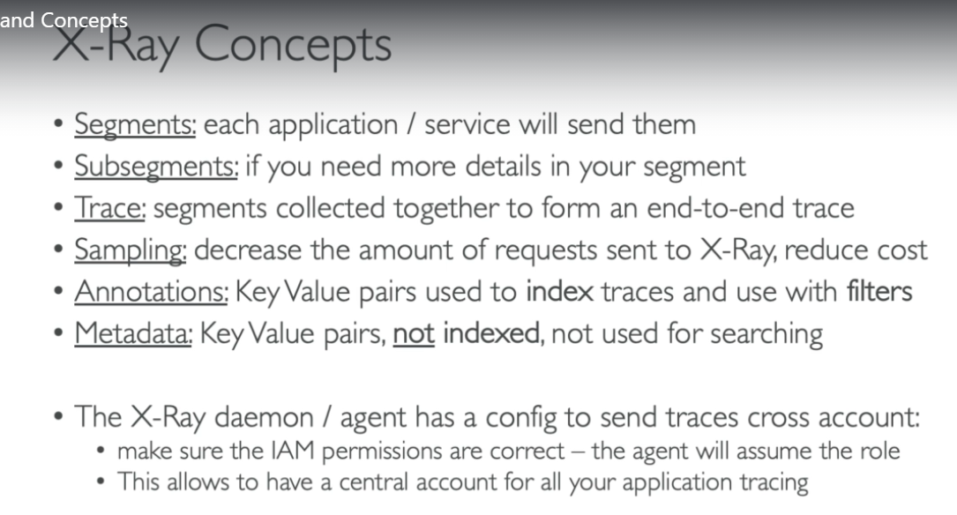

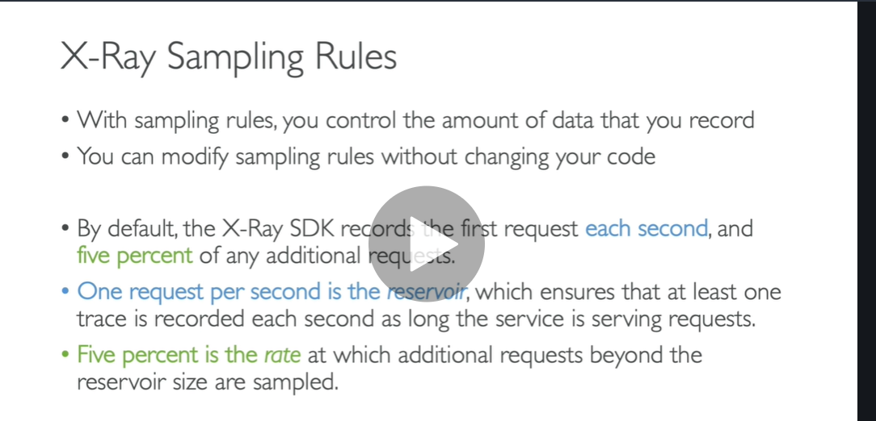

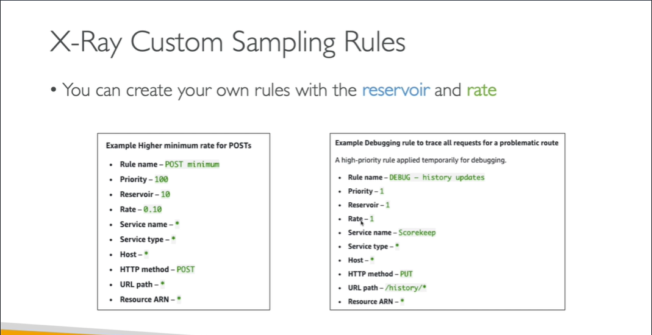

**X ray sampling rules**

By default, the **X**-**Ray** SDK records the first request each second, and five percent of any additional requests. One request per second is the reservoir. This ensures that at least one trace is recorded each second as long as the service is serving requests.

You can use AWS X-Ray console or SDK to configure sampling rules for your Amazon API Gateway API. A sampling rule specifies which requests X-Ray should record for your API. By customizing sampling rules, you can control the amount of data that you record, and modify sampling behavior on the fly without modifying or redeploying your code.

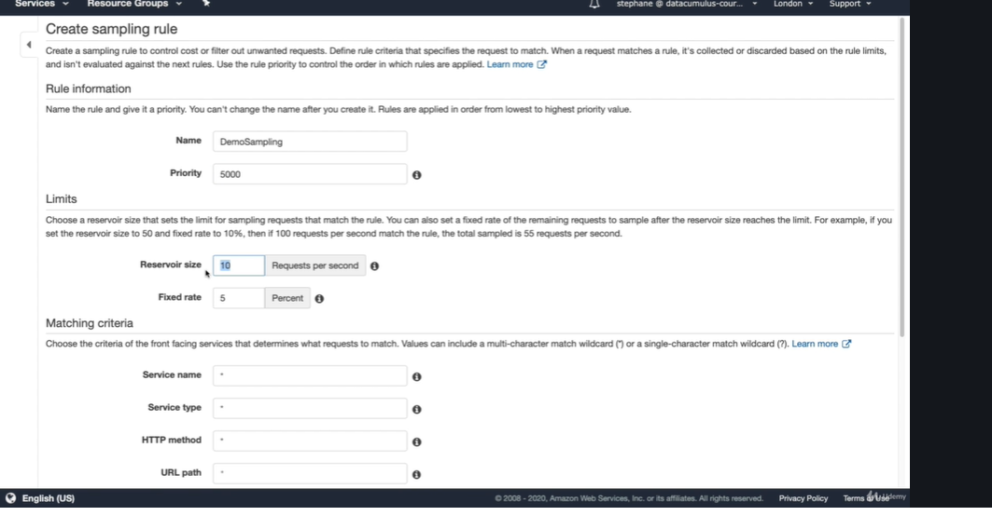

X rays API

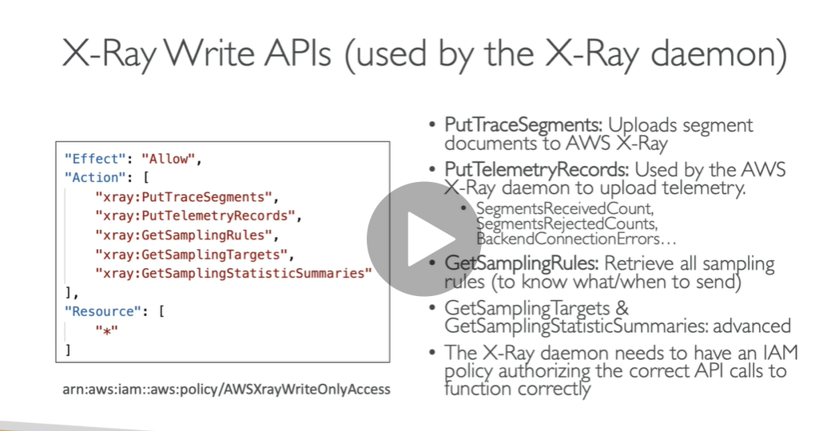

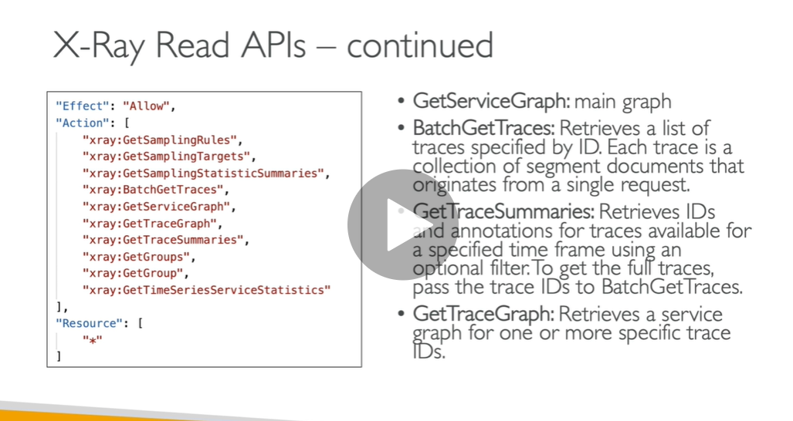

**Xray with beanstalk**

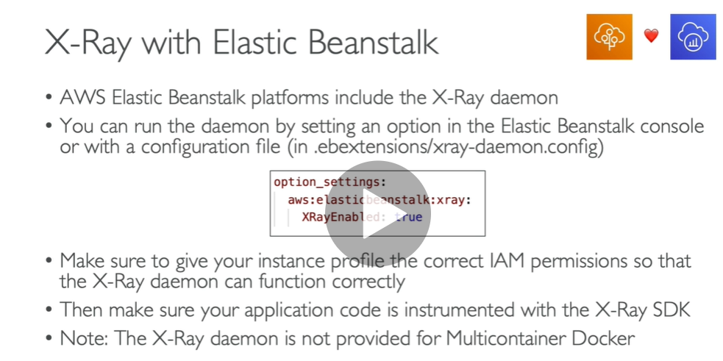

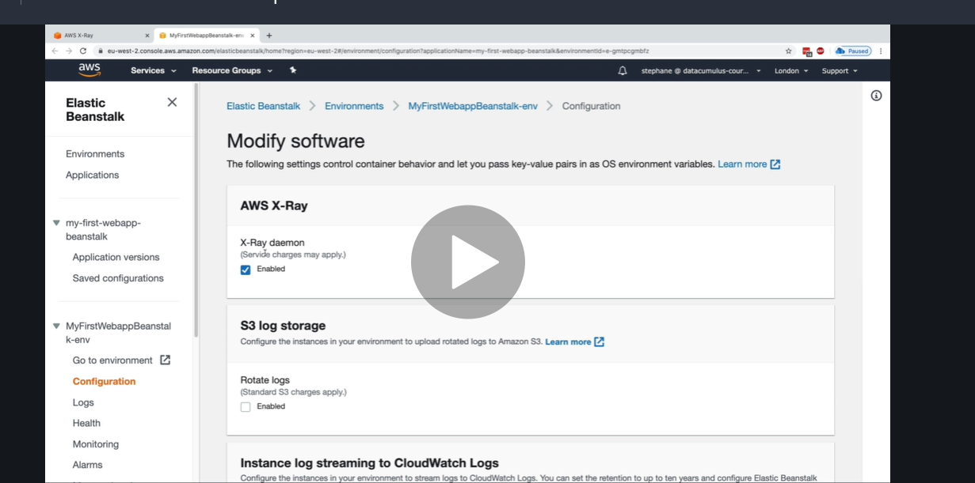

**But want to see ec2 instance have correct role**

**Go to health**

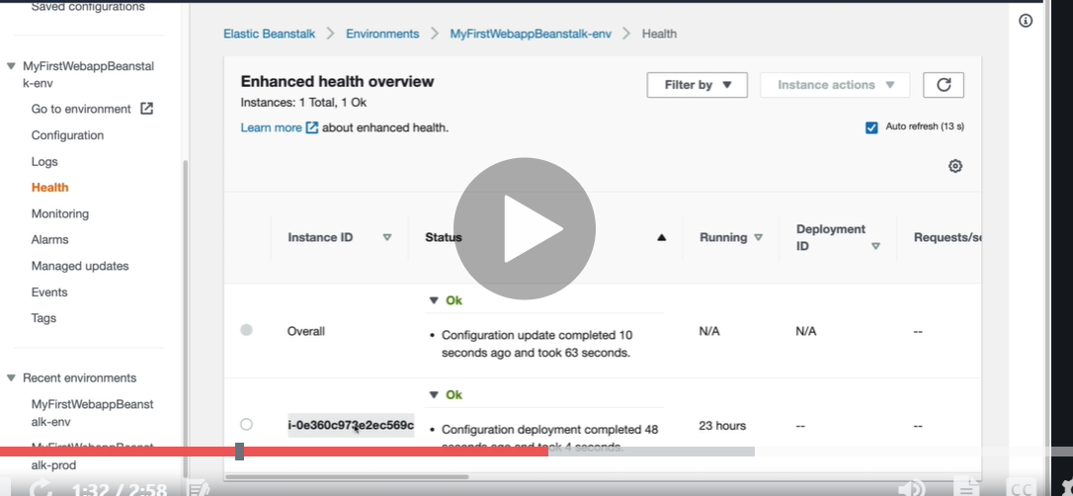

**Ec2 instance**

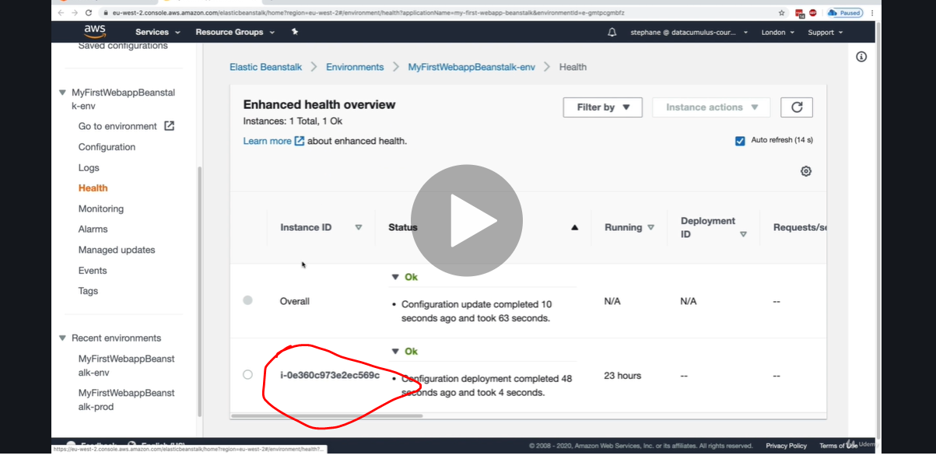

**For ec2 instance**

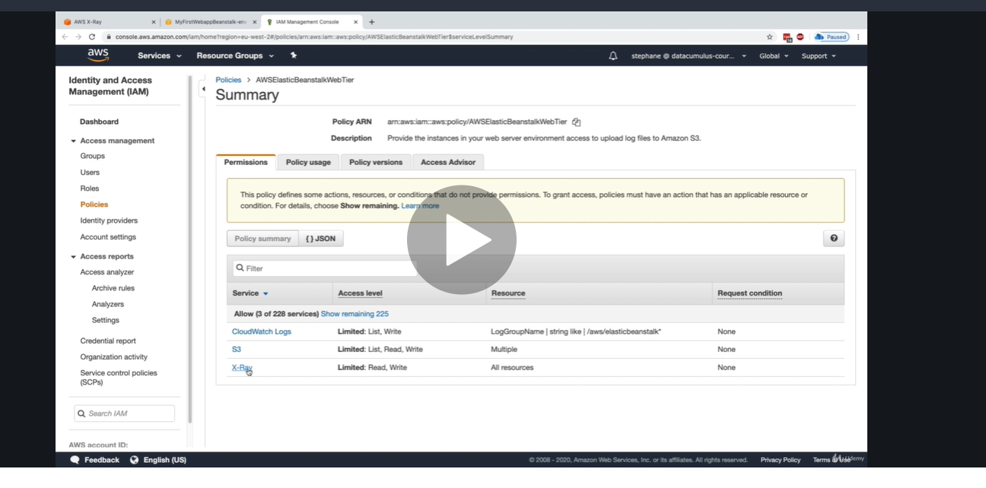

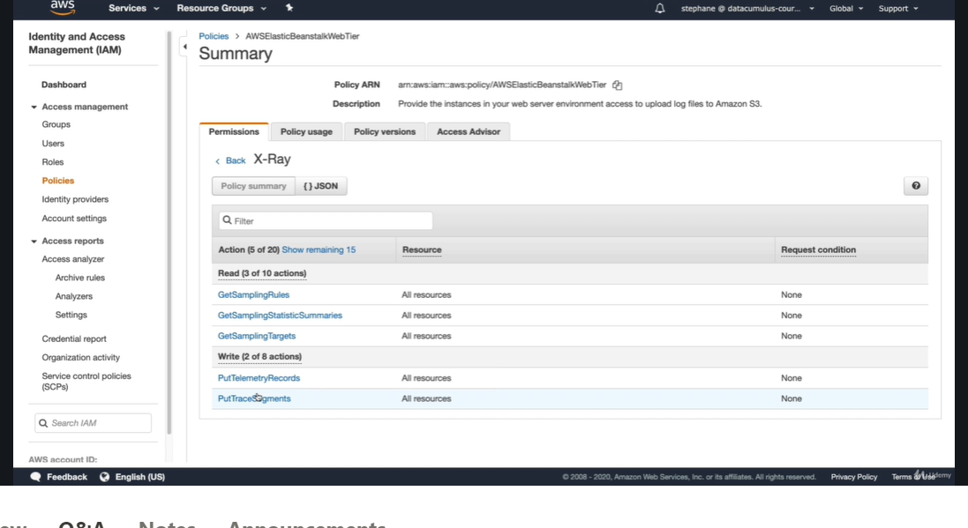

**Xray and ecs**

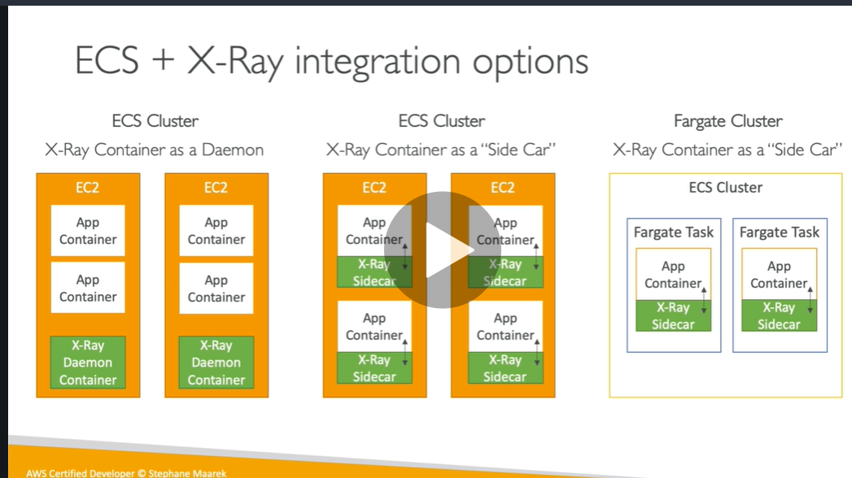

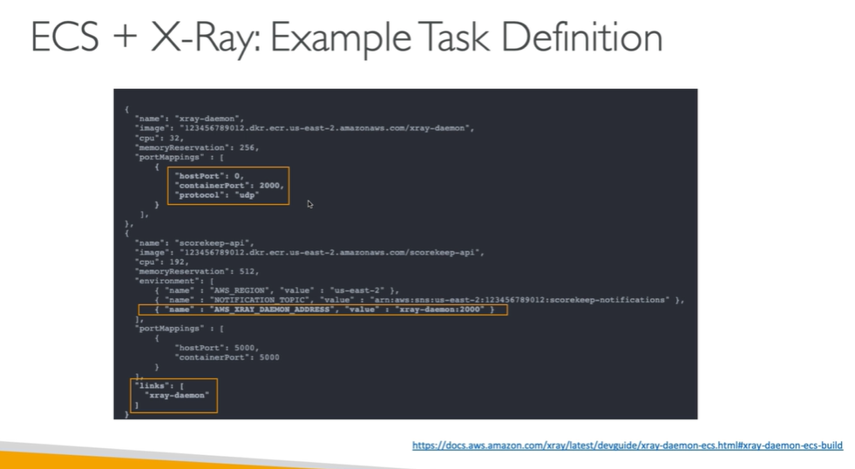

**AWS cloudtrail**

**Cloudtrail : we can track any api call that is done by anyone**

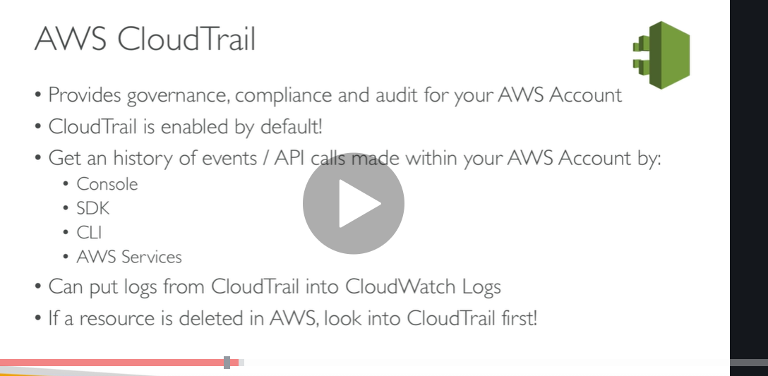

**All the recent events will come in cloudtrail**

**Imp**

